REPORT

SECRETARIAT OF THE BUSINESS
DEVELOPMENT AND INVESTMENTs
COUNCIL UNDER THE GOVERNMENT
OF THE KYRGYZ REPUBLIC

2016 ANNUAL REPORT

TABLE OF CONTENTS
INTRODUCTION 2
1. ACHIEVEMENT OF OBJECTIVES AND IMPLEMENTATION TASKS OF THE SECRETARIAT OF THE COUNCIL 3
I. Development of economic policy aimed at improving the country's investment climate 3
1.1. Activity 1 - Identification of barriers through a broad consultation process 3
1.2. Activity 2 - The process of preparing measures to improve business environment 7
1.3 Activity 3 - Informing about adopted decisions 9
1.4 Activity 4. - Interaction of the Secretariat with Parliament and Regions 17
II. ENSURING PARTICICATION OF BUSINESS CIRCLES AND DONOR COMMUNITY IN THE DECISION-MAKING PROCESS 23
1.5. Activity 5. - Analytical support to a process of public-private dialogue 23
1.6. Activity 6 - Improving a process of public-private dialogue 25
1.7. Activity 7 - Implementing decisions of the Council 27
III. Current activities of the Secretariat to achieve the set goals 29
1.8. Activity 8 - Managing process of public-private dialogue 29
1.9. Activity 9 - Capacity development of the Secretariat 30
1.10. Activity 10 - Reports of the Secretariat 31
2. MONITORING 31
3. EVALUATION OF RESULTS OF ACTIVITIES 32
CONCLUSION 34

INTRODUCTION

The Investment Council has shown over a 10-year period of its activity effectiveness in achieving the objectives of building a public-private dialogue (hereinafter - the PPD) in the Kyrgyz Republic. Currently, the Investment Council remains the only platform providing an effective process of a public-private dialog, with clear and well-developed mechanisms for identifying problems, submitting proposals for resolving problems, and monitoring an implementation of decisions. The change of Government in May 2016 did not lead to significant delays in an implementation of decisions of the Council, and the new Government also supported principles and mechanisms of public-private dialogue. All four meetings of the Investment Council were held almost at the agreed time. Both scheduled and urgent issues raised by the business community were considered at meetings. 15 business initiatives were considered and 39 recommendations were given to the Government. A number of Council’s members from the business community in 2016 have increased significantly, and now it is 56 business associations, which is 5 business associations more than that of 2015.

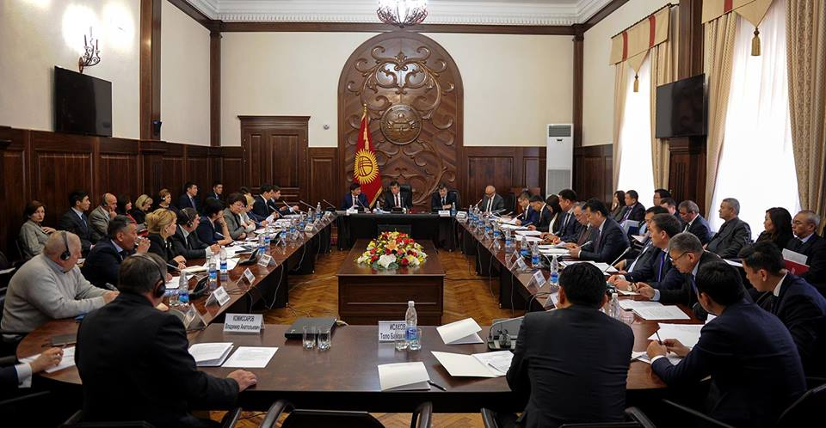
The EBRD decided to strengthen cooperation with the Parliament of the Kyrgyz Republic based on consultations with representatives of business associations. The Investment Council (IC), having close ties and a fruitful history of cooperation with the Government of the Kyrgyz Republic, at the same time had little interaction with the legislative branch. Parliament plays an important role in a process of PPD, since a large number of issues on the IC meeting’s agenda deals with changes in legislation and other normative legal acts.

At the same time, the Secretariat of the Council continued to work to strengthen the regional PPD. Thus, USAID supported the Secretariat of the Council in financing local experts in Osh and Naryn oblasts to strengthen stability of the secretariats of regional councils.

The EBRD has recruited two experts in July of 2016 to strengthen activities of the Secretariat of the Council: a consultant to build an effective interaction with the Jogorku Kenesh and a regional PPD expert.

The Secretariat of the Council maintains close relations with the donor community and constantly improves its joint work. In addition, the Secretariat of the Council continues to play a leading role in work of the Working Group on Private Sector Development, which brings together international projects of donor's coordinating group in order to improve an investment climate and the business environment.
In general, the Secretariat of the Council in 2016 managed to strengthen the PPD by including 3 members of the Parliament and a head of the department of financial and economic analysis and monitoring of development under the Office of the President of the Kyrgyz Republic. Corresponding amendment No. 261 was introduced on May 17, 2016 into an existing Government's Decision on an establishment of the Council.
All documents adopted by the Council for an implementation of its decisions are annexed to this report.

1. ACHIEVEMENT OF OBJECTIVES AND IMPLEMENTATION TASKS OF THE SECRETARIAT OF THE COUNCIL

Established activities of the Secretariat are divided into three interrelated groups of issues:
- development of economic policies aimed at improving the country's investment climate;
- organizational, technical and methodological support of business circles and donor community in a decision-making process;
- current activities of the Secretariat in achieving set goals.

I. Development of economic policy aimed at improving the country's investment climate

1.1. Activity 1 - Identification of barriers through a broad consultation process

- Identification of main investment obstacles to local and foreign enterprises, which are key participants in a process for consideration by the Investment Council.
Steps taken:
The work of the Council’s Secretariat in 2016 was based on the Work Plan of the Investment Council for 2016, adopted at a meeting of the Council on November 25, 2015 and based on proposals received from Council’s members, government agencies and business associations. The prepared plan includes both measures aimed at further improving an investment climate, as well as activities to implement specific projects (further development of the High-Tech Park, renewable energy sources, support of local jewelry manufacturers). In general, the Council's work plan for 2016 includes 21 proposals from 20 business associations. At the same time, it should be noted that the Plan is flexible, and at any time it may be amended by a decision of any member of the Council. Most of the activities are included in the plan in order to continuously monitor an implementation of ongoing reforms.
The following meetings of the council were held in 2016 for the topics indicated below.
Main issues:
Implementation of anti-crisis measures for 2015 and 2016
Export development
Development of the High-Tech Park
Problematic issues in the mining industry
Issues of movement of goods to / from the EAEU countries

Meetings of the Council:
- February 25, 2016
- June 30, 2016
- October 11, 2016
- Dec. 29, 2016

The EBRD decided to strengthen an interaction of the Council’s Secretariat with the Parliament of the Kyrgyz Republic based on consultations with the business community. In this connection, experts of the Council’s Secretariat took part in a number of meetings with the deputies of the Parliament to clarify principles of the PPD. Based on requests of deputies of the Parliament of the Kyrgyz Republic, experts of the Secretariat of the Council prepared a number of analytical notes and recommendations.

Experts of the Secretariat of the Council assisted business associations in resolving urgent issues. Together with business associations, the Secretariat of the Council developed appeals concerning various issues requiring attention and prompt response of the President of the Kyrgyz Republic, the Prime Minister of the Kyrgyz Republic, the Jogorku Kenesh of the Kyrgyz Republic.

Experts of the Secretariat carry out consultations to obtain advice from all interested parties on issues raised at Council's meetings. The constant participation of experts from the Secretariat of the Council in interdepartmental commissions and working groups allows us to work out joint recommendations on all issues of interest.
Experts of the Secretariat of the Council participate in conferences and roundtables to identify problematic issues of the business community, as well as to promote issues initiated by business associations at meetings of the Council.
Prepared documents: The following documents were adopted in order to implement this activity in 2016 (see Appendices):
- Minutes of the meeting of the Council from February 25, 2016;
- Minutes of the meeting of the Council from May 30, 2016;
- Minutes of the meeting of the Council from October 11, 2016;
- Minutes of the Council meeting from December 29, 2016;
- Council's Work Plan for 2017
- Analysis of socio-economic consequences of adoption of the Law of the Kyrgyz Republic on January 26, 2016 No. 12 "On Amendments to the Law of the Kyrgyz Republic “On Enactment of the Tax Code of the Kyrgyz Republic”."
- Study of the socio-economic consequences of adoption of the draft Law of the Kyrgyz Republic "On Amendments to the Tax Code of the Kyrgyz Republic" which provides for an exemption from VAT on raw gold and silver alloy materials in cases of supply of goods, works and services by a domestic jewelry manufacturers.
- Regulations, work order and internal procedures of the Methodological Council under the Jogorku Kenesh (JK).

Results: As a result of an implementation of this activity, the Secretariat of the Council continued work ensuring an operation of the PPD platform at a high level. The voice of the business community has intensified.

- Carry out consultations with the EBRD and receive recommendations (feedback) from government bodies / departments, the private sector, as well as international financial institutions and other donor organizations
Steps taken:
Based on consultations conducted with representatives of business associations, specifically with Mr. Steves, director of the EBRD Investment Climate and Governance Group, it was decided to strengthen interactions of the Council's Secretariat with the Parliament, as well as to strengthen and expand regional councils.
Experts from the Secretariat of the Council in 2016 held the following meetings and consultations with the EBRD to obtain recommendations, as well as to determine further activities of the Council's Secretariat:
- T. Koichumanov, the Head of the Secretariat met with Mr. Masaru Honma, the Director of the EBRD for Central Asia, on April 7, 2016. Main results of activities of the Secretariat of the Council in the Kyrgyz Republic were discussed at the meeting with Mr. Honma, Mr. Koichumanov informed about activities in strengthening PPD and about the subsequent plans in this area.
- Experts of the Council’s Secretariat met with Mr. McCain, EBRD Director for Central Asia and Ms. Rodina, Senior Advisor to the EBRD Group on October 3, 2016 in regards to Investment Climate and Governance. Experts of the Secretariat of the Council acquainted EBRD representatives with activities of the Secretariat and with all the latest work achievements. They also discussed at the meeting a possibility of establishing the institution of a business ombudsman.
- Council's Secretary T. Koichumanov met with Ms. Lisa Rosen, Managing Director of the EBRD, Head of the Corporate Regulation and Control Department on October 24, 2016 to discuss general provisions on the Anti-corruption Policy of the Kyrgyz Republic, as well as current situation in the country.
- Council's Secretary T. Koichumanov met with Mr. Agris Primanis, EBRD Regional Lead Economist and Mr. Arthur Radziwill, EBRD Country Strategy and Policy Director on December 14, 2016. The following issues were discussed at the meeting:
- economic changes in the country;
- impact of a decrease in volume of money transfers and participation in the EAEU;
- problems of the business environment;
- key priorities of the Investment Council in 2017;
- potential directions for long-term growth;
- priority structural reforms.

Experts of the Secretariat of the Council constantly carry out consultations to obtain recommendations from all interested parties on matters raised at the Council's meetings. The constant participation of experts from the Secretariat of the Council in interdepartmental commissions and working groups allows us to work out joint recommendations on all issues of interest.
Experts of the Secretariat on an ongoing basis carry out consultations with major projects of international organizations aimed at improving business environment and investment climate in order to inform about preformed work and coordinate their actions. In particular, the Secretariat of the Council plays an important role in activities of the working group on donor's coordinating group in order to improve an investment climate and the business environment.
Prepared documents: minutes of meetings of working groups, interdepartmental commissions, Government Decree on a creation of the Council.
Results: Work mechanisms have been developed that take into account recommendations of stakeholders that are sustainable.

1.2. Activity 2 - The process of preparing measures to improve business environment

- Determine issues to be addressed in coordination with members of the Council, ensure agreement and preparation of the agenda, including provision of the necessary documents to be discussed at meetings of the IC and working groups.
Experts of the Secretariat of the Council held regular meetings with members of the IC to discuss agenda of the forthcoming meetings of the Investment Council, an implementation of the adopted decisions, and clarification on proposed topics for consideration by the Council.
The work plan was formed on a basis of meetings with members of the IC. It stipulates topics for the subsequent meetings of the Investment Council.
The work plan is based on 4 principles:
- Continuous monitoring of an implementation of adopted decisions
- Significance and relevance of raised issues
- Feasibility of raised issues in the medium term
- Problem setting by the business itself

In 2016, the Council work was based on the 2016 Council's Work Plan, approved at a meeting of the Council from November 25, 2015. Business associations initiated all issues included in the Work Plan.
The approved plan included activities aimed at further improving the investment climate, as well as activities to implement specific projects. At the same time, most of the measures were introduced into the plan in order to continuously monitor an implementation of ongoing reforms, such as: customs administration, tax administration, optimization of the licensing system, export-import operations. The Investment Council paid much attention in 2016 to problems of small and medium-sized businesses in joining the Eurasian Economic Union. In addition to planned issues, in included such issues as: development of the High-Tech Park, unification of the electronic digital signature, support of local jewelry manufacturers, problems of the mining industry.
The Council's Secretariat organized a round table on strengthening PPD on September 2-4, 2016 to discuss the Council's Work Plan for 2017. A resolution was adopted and a draft 2017 Work Plan was created at the end of the round table. The Work Plan includes such issues as improving tax administration, developing tourism: electronic visas and open skies, creating laboratories that approve agricultural products, conditions for ensuring food security, and many other subjects. It was decided to include regional reports for the discussion at meetings of the Investment Council at a request of regional council representatives. The Action Plan was approved at a meeting of the Council on December 29, 2016. About 50 representatives of business associations, state bodies, international organizations, regional investment councils took part in discussion of the Council's 2017 Work Plan.
Prepared documents: Normative legal acts initiated by business associations and donor organizations, which are described in detail under activities of the Secretariat in 1.6.
- Conducting regular meetings of the Council and working groups
According to the statute on IC, meetings of the Council are held as required, but not less than once a quarter. In 2016, 4 meetings of the Council were held - on February25, on May 30, on October 11, on December 29.
As part of implementation of decisions adopted at the Council's meetings in 2016, new working groups and commissions were created, and some of earlier created commissions continued their work. Secretariat The Council initiated an establishment of an Interagency Advisory Body on technical regulation of food products and on application of sanitary, veterinary and phytosanitary measures. In general, activities of these working groups are interconnected with main areas of the Council's activities.
In particular, such groups are:
- The Interdepartmental Commission on a coordination of tourism development, formed by the Decree of the Prime Minister of the Kyrgyz Republic on February 24, 2016 No. 98

- Interdepartmental Working Group on a development of a systemic legal protection model of business entities and local governments from unreasonable inspections of their activities by law enforcement and tax authorities, formed by the Decree of the Prime Minister of the Kyrgyz Republic No. 154 from April 4, 2016.

- Working group to study a possibility of improving the system and reducing rates of payment for environmental pollution, stipulated by Government Decree from September 10, 2015, No. 625, created by the Order of the State Committee for Industry, Energy and Subsoil Use No. 236 from August 15, 2016.

- Interdepartmental Working Group to consider a proposal of the International Business Council to improve system for cost-setting standards in compensation for agricultural losses, established by Government Decree No. 1 from January 5, 2016, established by the Ministry of Justice Order No. 203 from November 18, 2016.

- Interdepartmental Working Group on preparation of procedures for determining value of goods in customs clearance, excluding subjective application of various rates to participants in foreign economic activities, created by the Ministry of Economy of the Kyrgyz Republic's order No. 304 From November 3, 16.

- Working Group on a development of proposals to identify technical requirements for the computer system, which provides online data transfer into the automated data system KKM online, created by the Order of the State Tax Service under the Government of the Kyrgyz Republic No. 251 from November 9, 2016.

- Interdepartmental Working Group on creating conditions for a development of small hydropower stations, established by an Order of the State Committee for Industry, Energy and Subsoil Use of the Kyrgyz Republic No. 376 from November 16, 2016.

All working and expert groups were created with a participation of representatives of business associations, international donors and experts of the Secretariat.
Prepared documents: Minutes of the Council's meetings were adopted and signed by the Chairman and Secretary of the Council, resolutions and orders on creation of working groups and interdepartmental commissions were established and adopted in order to implement decisions of the Council.
Results: Members of the Council were extensively involved in a process of developing documents for meetings of the Council. Recommendations of the donor community and business associations were taken into account in activities of the Government.

1.3 Activity 3 - Informing about adopted decisions

- Preparation of presentations, conclusions and recommendations of the Council and / or working groups for consumption by the state bodies, representatives of the private sector and the EBRD, if necessary.
Experts of the secretariat hold regular working meetings with representatives of business associations, informing them about adopted decisions and their implementation. The Secretariat also constantly provides an opportunity to business associations, projects of international organizations to hold meetings to discuss problems of private and public sector. The Secretariat constantly provides its platform for meetings with the business community to all interested parties.
The Secretariat of the Council on a regular basis updates its website, as well as leads a page of the Investment Council in Facebook social network. All news and documents received are promptly posted on these resources, as well as announcements of events, news and achievements of the Council are sent the e-mail addresses of all association members. The Secretariat is also actively working with all media sources.
Experts of the Council's Secretariat took part in the following events in 2016 to inform stakeholders about activities of the Council:
T. Koichumanov on January 18, 2016 met with S. Osovalyuk, the Head of the IFC Project on Sustainable Development to discuss development of cooperation in strengthening public private dialogue in the Issyk-Kul region. The timeline of the IFC project on the Development of the Dairy Industry in Issyk-Kul oblast and potential components of the project to support public-private dialogue through regional investment council’s platforms were discussed during the meeting.
B. Asanov, the Secretariat's expert took part in the round table on January 21, 2016 on results of the project "One Village - One Product" and discussed further steps to promote this project.
A meeting was held on January 27, 2016 at the office of the Secretariat of the Council to discuss proposals for an improvement of legislation regulating entrepreneurial activity. Representatives of the OSCE project "System Analysis of Regulation", Association of Small Hydro Power Plants, Association "Economic Chamber", Union of Jewelers and Entrepreneurs of the KR, Suppliers Association, JIA Business Association, International Business Council, National Alliance of Business Associations and Chamber of Commerce and Industry of the Kyrgyz Republic participated in this meeting.
T. Koichumanov, the Head of the Secretariat held a meeting on February 4, 2016 with Japan Association for Trade with Russia and the Newly Independent States (hereinafter JATRNIS), headed by Mrs. Vazhima, the Director of the JATRNIS Institute for Economic Research of Russia and Newly Independent States. Issues of further development of cooperation between the countries and activation of the Japan-Kyrgyz Network website for improving the investment environment we discussed at the meeting.
T. Koichumanov, the Head of the Secretariat, met with a delegation from the International Fund for Agricultural Development on March 11, 2016 in order to discuss development of a new project to support livestock industry. Issues and opportunities for cooperation on this area were discussed at this meeting.
A round table "The Role of Investments in Economic Development" was held under the chairmanship of T. Sariyev, the Prime Minister of the Kyrgyz Republic on March 29, 2016. The National Institute for Strategic Studies and the Secretariat of the Investment Council organized the round table. The Prime Minister noted an importance of the event and stressed that the Government takes all possible measures to improve conditions for doing business in the country. During the meeting, representatives of international and business organizations exchanged information on a situation in the country and discussed issues related to the development of the country's economy.
A round table under the chairmanship of T. Sariyev, the Prime Minister of the Kyrgyz Republic was held on March 30, 2016 in the Hyatt hotel to discuss a draft program for the development of tourism in the Kyrgyz Republic until 2020. The Director of the Department of Tourism under the Ministry of Culture, Information and Tourism (MCIT) presented a draft tourism development program. T. Koichumanov, the Head of the Secretariat of the Council made proposals for consideration, within the framework of finalizing this program, touching upon issues in:
- development of sanitary and epidemiological standards for temporary tourist camps;
- assigning a status of "Natural Monuments" to especially valuable natural objects;
- amendments to regulatory legal acts providing for a possibility of building facilities on the lands of the forest fund;
- development and implementation of the "Open Sky" policy.
All proposals based on the results of the round table discussion were recorded for further elaboration and inclusion in the draft program.
The International Forum "Eurasian Economic Perspective" was held on April 8, 2016at the Congress Hall of the State Residence No.1 "Ala-Archa", within the framework of the working visit to the Kyrgyz Republic of S. Naryshkin, the Chairman of the State Duma of the Federal Assembly of the Russian Federation. This forum was designed to promote further mutually beneficial development of trade and economic relations between the countries of the EAEU. The representatives of the state structures of the EAEU countries, representatives of the Eurasian Economic Commission (EEK), business associations, chambers of commerce and industry, as well as representatives of small, medium and large businesses attended this event. T. Koichumanov, the Head of the Council’s Secretariat made a presentation on "Business Community Issues” on doing business in EAEU.
T. Shakeev, an expert of the Secretariat attended the Forum on protection of private property on April 11, 2016. The Bishkek Business Club in conjunction with the Parliament of the Kyrgyz Republic organized the forum.
T. Shakeev, an expert of the Secretariat took part in the international conference "Business against corruption: current challenges and trends" on April 19, 2016. The purpose of the conference was to show an importance of a role of the business sector of Kyrgyzstan in a prevention of corruption, as well as in raising awareness of key players in a prevention of corruption in Kyrgyzstan and to introduce a new anti-corruption mechanism "Business Compliance".
T. Koichumanov, the Head of the Council's Secretariat participated in the III Asian-European Business Innovation Congress (AEBIC) in Almaty held on April 21-22, 2016. The purpose of this event was to create a business platform for a development and strengthening of interaction between East and West in an area of industrial and innovative growth for small and medium-sized businesses.
The scientific and practical conference "Logistics Management for Economic Development" was held on May 18, 2016. T. Koichumanov, the Head of the Council's Secretariat was a moderator at the conference. The main objective of the conference "Logistics Management for Economic Development" was to present and discuss reports on results of academic and expert work, namely establishment of trade and logistics centers on a territory of the Kyrgyz Republic and the best international practices in an area of logistics management. A compilation of reports from participants of this scientific and practical conference was published as a result of this event.
A training seminar on logistics with international experts and practitioners was held on May 18-20, 2016. This seminar was developed on a basis of materials developed by the WTO's International Trade Center.
A. Seitbekov, an expert of the Secretariat took part in the round table held at the Plaza Hotel on May 23, 2016, on a topic: "Warehouse evidence as a financial tool for a development of agriculture in the Kyrgyz Republic: discussion of the draft law of the KR" On warehouse certificates”.
A. Seitbekov, an expert of the Secretariat on June 10, 2016 participated in the meeting of the interdepartmental commission for development of ski cluster under the chairmanship of O. Pankratov, the Vice Prime Minister. Action Plan for the project in questions was discussed at the meeting.
The Secretariat of the Council held a roundtable discussion on July 6, 2016, on the draft law on food safety, initiated by the Ministry of Health of the Kyrgyz Republic. Representatives of the Ministry of Economy, Suppliers Association, NABA, Association of Fruit and Vegetable Enterprises, Association of Markets, experts and representatives of international projects took part in the round table. Participants noted in a course of the round table discussion that the draft Law needs to be further amended taking into account the inability to date of small producers in Kyrgyzstan to meet requirements of the draft law and technical regulations of the EAEU. As a result of the round table, it was decided to finalize the draft law in accordance with proposals of entrepreneurs.
T. Koichumanov, the Head of the Council's Secretariat took part in a meeting of the Council on July 7, 2016 on Regulatory Reforms chaired by S. Jeenbekov, the Prime Minister of the Kyrgyz Republic. Participants of the meeting considered the first package of recommendations to the regulatory legal acts regulating entrepreneurial activity developed within the framework of an implementation of the regulatory reforms. The main objective of the regulatory reforms is to simplify administrative procedures and create the most favorable conditions for doing business in the country.
K. Ashyrkulov and B. Asanov, experts of the Council's Secretariat took part in the III Economic Forum "Issyk-Kul 2016" in Cholpon-Ata on July 22, 2016. The Forum was devoted to issues of deepening business cooperation, stimulating joint development and prospects for cooperation in selected economic sectors. The Forum was held in several sections: agriculture and industry, financial sector, tourism and health, small energy and renewable energy sources, free economic zones. The official and business delegations from China (Hubei, Wuhan, Shaanxi, Xi'an, Xinjiang, Urumqi provinces, as well as from the provinces of Wujiaqi and Kuitun) took part in the Forum.
K. Ashyrkulov, an expert of the Secretariat's took part in the round table " Business problems in leading sectors of the economy and ways to solve them", organized by the International Business Council on July 27, 2016. Problems and proposals in three main areas of involvement: Financial sector, Telecommunications and Mining were presented at the round table.
K. Ashyrkulov, an expert of the Secretariat and T. Koichumanov, the Head of the Secretariat met with the leading expert of the Secretariat of the Ata-Meken faction of the Kyrgyz Parliament on August 18, 2016. The Secretariat's staff at the meeting familiarized the expert with the goals, status and main activities of the Council. Main problems and shortcomings in interaction with the Jogorku Kenesh were also voiced. As a result of this meeting, an agreement was reached on cooperation and information exchange between the faction and the Council.
T. Koichumanov, the Head of the Council's Secretariat on August 23 took part in the round table held by the National Alliance of Business Associations on "The Role of Business Associations in an Establishment of a Sustainable Economy of the Kyrgyz Republic."
A. Akeneev, an expert of the Secretariat participated in a roundtable discussion on the draft law "On Food Safety" on August 23, 2016.
T. Shakeev, an expert of the Secretariat attended the 2nd meeting of the National Business Club on September 28, 2016. The round table discussed reforms in law enforcement agencies of the Kyrgyz Republic and a role of the state and the business.
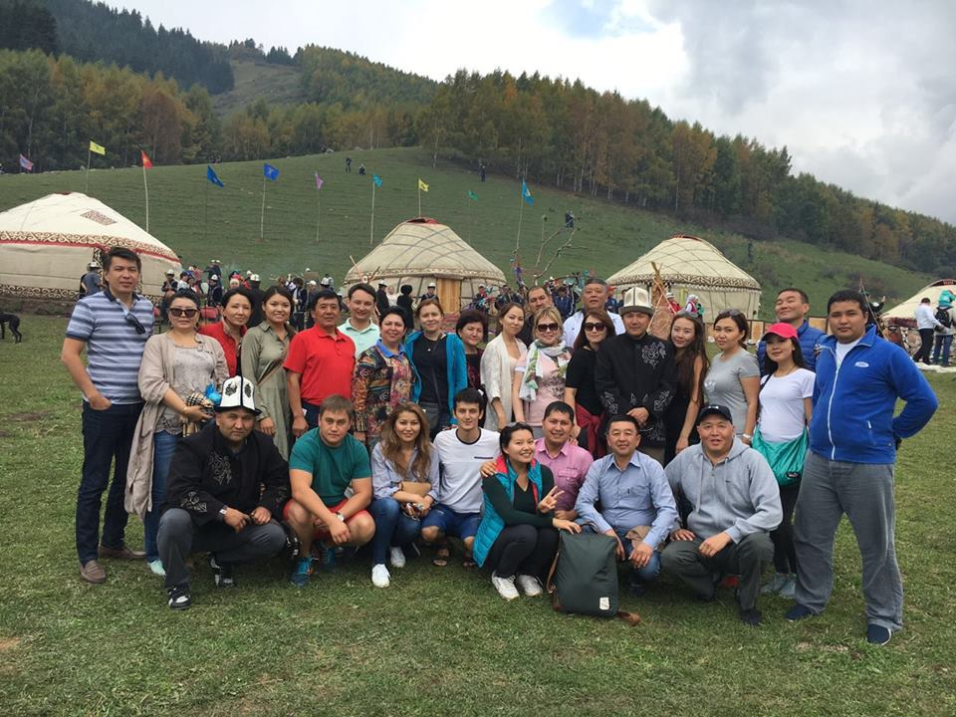
An annual a round table was held on September 2-4, 2016 at "Meridian" resort on strengthening the PPD. The round table is held from 2012. The main purpose of the round table is to discuss the Council's Work Plan for 2017, as well as other necessary reforms to improve the business environment and investment climate. The round table was organized by the Secretariat of the Council for Business and Investment Development under the Government of the Kyrgyz Republic with a support of the USAID BGI Project - the Kyrgyz Republic. More than 55 representatives of business associations, government bodies, international organizations, regional investment councils attended the round table.
Bishkek Liberal Club with the support of the Friedrich Ebert Foundation held a meeting on September 15, 2016 on a subject - Economic interests of Kyrgyzstan within the EAEU. Representatives of expert circles, government agencies, as well as business associations attended the roundtable. T. Koichumanov, The Head of the Secretariat made a presentation on a subject of "Business community initiatives related to the accession of Kyrgyzstan to the EAE". Professor Koichumanov touched upon the main issues and problems in his report, related to the accession of Kyrgyzstan to the EAEU, which were initiated and considered at the Council's platform level. In addition, participants discussed a current situation of entrepreneurs involved in foreign economic activity with the EAEU countries.
The Secretariat's experts took part in the Kyrgyz-Czech business forum on September 28, 2016, organized by the Czech Ministry of Foreign Affairs and the Russian-Kyrgyz Development Fund within the framework of bilateral economic cooperation. The Prime Minister of the Kyrgyz Republic, the Ambassador of the Czech Republic, representatives of the Ministry of Agriculture of the Kyrgyz Republic and over 40 major Czech manufacturing companies attended the meeting. A memorandum on cooperation between the Czech Export Bank and the Russian-Kyrgyz Development Fund was signed at the forum.
A round table " SMEs Business Agenda" was held on October 14, 2016 with a support of the Secretariat of the Council. The event was organized by BizExpert analytical center in partnership with the Investment Council and leading business associations of the country - IBC, JIA, CCI KR, NABA, UEK. Main business problems were discussed at the round table for their inclusion in the country's development strategy, without expecting a new strategic document.
T. Koichumanov, the Head of the Secretariat, and K. Ashyrkulov, the Council's expert on October 25, 2016 took part in the meeting of the Committee on Economic and Fiscal Policy under the Jogorku Kenesh of the Kyrgyz Republic. Information on the mission, objectives, structure of the organization and the principles of the Investment Council was provided at the meeting. In addition, proposals were submitted for more effective interaction between the Council and the Committee on Economic and Fiscal Policy under the Jogorku Kenesh of the Kyrgyz Republic.
K. Ashyrkulov, an expert of the Secretariat on November 11, 2016 took part in a roundtable organized by the Bishkek Business Council (BBC) to discuss an amendment to the Law of the Kyrgyz Republic "On External Migration", according to which new requirements for compulsory registration of foreign citizens staying in the Kyrgyz Republic were established. The deputy of the parliament, representatives of state bodies and the business community took part at the round table. The purpose of the round table was to discuss negative consequences of the adoption of new registration requirements and proposals of business associations on abolition of these requirements. Based on results of the round table, participants adopted a resolution and sent it to the Parliament and the state authorities.
The business community met at the Secretariat's office on November 16, 2016 to discuss the Council's Work Plan for 2017.
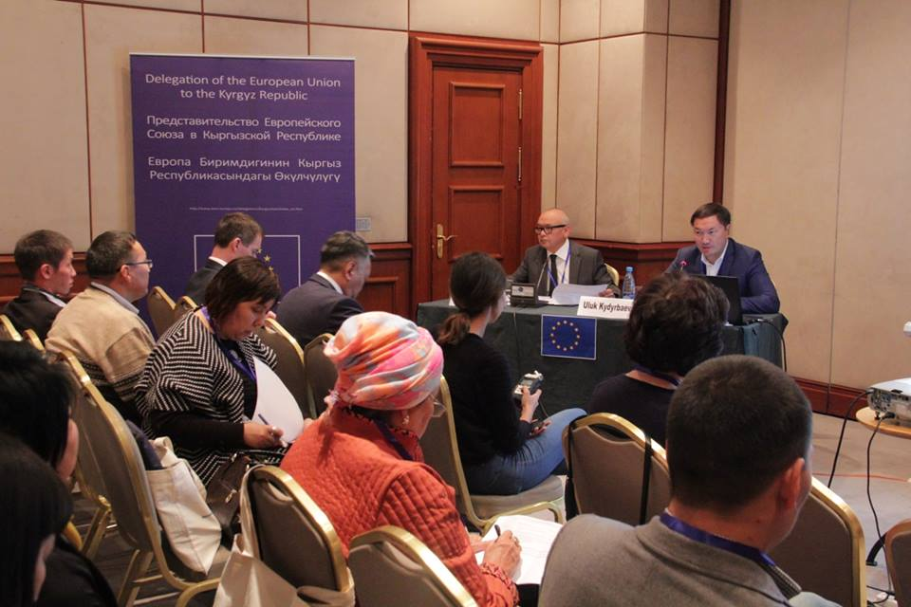
A civil society European Union - Kyrgyz Republic 2016 - fighting corruption seminar was held in the Hayat Hotel on November 17-18, 2016. T. Koichumanov, the Head of the Council's Secretariat, moderated a discussion on "Corruption in the private sector and business ethics". Representatives of civil society and public officials, independent experts from Kyrgyzstan, EU member states and joining countries, countries of the former USSR and international organizations attended the seminar. Recommendations developed by participants will be considered in the framework of the EU-funded program "Promoting the rule of law in Kyrgyzstan, with a special focus on transparency and accountability" implemented by GIZ in cooperation with a consortium of agencies of EU member states, the Council of Europe, EU and KR NGOs, and also media organizations.
The Interagency Advisory Body held a meeting at the Secretariat of the Council on November 18, 2016 on food technical regulations and the application of sanitary, veterinary and phytosanitary measures. Representatives of the Government of the Kyrgyz Republic, the Ministry of Economy of the Kyrgyz Republic, the Ministry of Agriculture, Food and Reclamation of the KR, the Ministry of Health of the KR, the State Inspectorate for Veterinary and Phytosanitary Security under the Government of the KR, the Dairy Union and the Association of Fruit and Vegetable Enterprises participated in the meeting.
A. Akeneev, an expert of the Secretariat on November 23, 2016 participated in the conference "Tools for interaction of state bodies with the business community." The purpose of the conference was to inform the business community about carried out work in an area of improving interactions between state bodies and the business community, as well as involving the business community in monitoring of such activities. First results in functioning of feedback mechanism in the state control agencies, the work of the State Agency for the Promotion of Investments and Export under the Ministry of Economics on a resolution of investor complaints, a brief report on changes introduced into the Law of the Kyrgyz Republic "On Inspections" were presented at the conference.
A. Seitbekov, an expert of the Secretariat on November 24-25, 2016 took part in a practical conference: "The four degrees of freedom in the EAEU: the movement of goods, labor, services and capital. Experience and lessons learned. "
A. Seitbekov, an expert of the Secretariat on November 30, 2016 took part in the round table "State control as an instrument for protecting consumers from products that do not meet the established requirements: problems and ways to solve them." The purpose of this roundtable was to discuss a situation at the domestic market, to gather information directly from business participants to better understand current problems, and to develop recommendations for protecting the domestic market in cooperation with the business community.
A. Seitbekov, an expert of the Secretariat on December 5, 2016 took part in the round table: "An introduction of lien financing on warehouse certificates. The draft Law of the Kyrgyz Republic "On trade warehouses and warehouse certificates” was discussed at the round table.
A. Akeneev, an expert of the Secretariat took part on December 8, 2016 in the scientific and practical conference "25 years of independence of the Kyrgyz Republic: results and strategies for the future" in the large conference hall of the Congress Hall of the State Residence "Ala-Archa" organized by the National Institute for Strategic Research together with the Friedrich Ebert Foundation. The purpose of the conference was to assess the economic, political, and moral-spiritual aspects of Kyrgyz society and the state development over the years of independence. State officials, expert and scientific community, representatives of state bodies, and the media attended the conference.
T. Koichumanov, the Head of the Secretariat participated in the 2016 Bishkek Investment Forum on December 8, 2016. Over 600 guests took part in the event. These were representatives of the official authorities of Kyrgyzstan and participants who came from all regions of Kyrgyzstan and foreign countries, including a delegation from India, which included 21 people. In total, over 150 entrepreneurs from the regions came to the Bishkek Investment Forum. Fourteen best business projects were presented to foreign investors, 8 to local investment institutions, as well as to representatives of large business and commercial banks of Kyrgyzstan. They were selected from over 250 applications received from local entrepreneurs.

Prepared documents: Presentations on activities of the Investment Council and the Secretariat and, in general, on the investment climate of the Kyrgyz Republic.
Results: Increased awareness of the business community, international partners and government agencies of activities of the Council.

1.4 Activity 4. - Interaction of the Secretariat with Parliament and Regions

- Interaction of the Secretariat with the Parliament of the Kyrgyz Republic

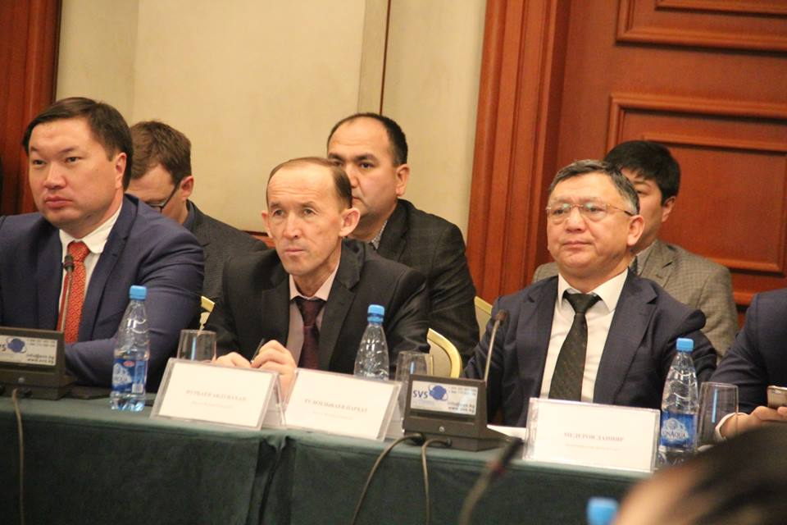
A number of meetings were held with the deputies of the Parliament in order to get acquainted with the purpose, objectives and main activities of the IC. First of all, meetings were held with three deputies D.D. Beksheev, G.K. Asylbaeva and P.R. Tulendybaev, members of the IC. In addition to IC activities, information was provided on issues on the current agenda of the IC. Separately, detailed information on each item of the agenda, together with the draft decisions were sent to deputies. Concrete proposals and comments were received from MP G.K. Asylbaeva on the agenda of the IC meeting, which were sent to the relevant ministries and state bodies (10 ministries and state bodies).
To increase an effectiveness of interactions with the JK office, proposals for cooperation were sent to the JK office; in addition, a draft memorandum on cooperation was drafted, which is currently under consideration in the JK.
Separately, a written letter was sent with detailed information on activities of the IC and possible closer cooperation with the parliamentary factions of the Jogorku Kenesh. In continuation of the sent letter, a meeting was held with I. Sh. Omurbulov, the leader of the Social Democratic Party of Kyrgyzstan (SDPK) parliamentary faction, in addition to exchanging information on IC activities at the meeting, an agreement was reached on cooperation in providing an analytical report on various legislative initiatives related to state regulation of business activities.
Thus, one of the first analytical documents for the SDPK Parliamentary Group was an analysis of the socio-economic consequences after adoption of the Law of the Kyrgyz Republic No. 12 from January 26, 2016 "On Amendments to the Law of the Kyrgyz Republic On the Enactment of the Tax Code of the Kyrgyz Republic." This law provided for VAT exemption for import of grains intended for processing by the importer and delivery of flour produced by the importer before September 1, 2018. The purpose of this law was to preserve production and processing of wheat grains and flour, as well as creation of competitive conditions in the flour market. Based on analysis performed by IC experts, it was concluded that an adoption of the law on an exemption from VAT of grain imports did not achieve its goals.
The next analysis carried out for the JK was to study the socio-economic consequences of an adoption of the draft Law of the Kyrgyz Republic "On Amendments to the Tax Code of the Kyrgyz Republic" providing for the exemption from VAT of gold and silver alloy raw materials for the supply of goods, works and services by domestic jewelry manufacturers. Also, sales by entities and physical persons of gold and silver alloy raw materials to domestic jewelry manufacturers are exempted from sales tax payment. IC experts organized and conducted a number of joint meetings and discussions with representatives of the jewelry industry and employees of the JK Office's legal department as part of the analysis and research. Based on analysis by IC experts, it was concluded that an adoption of the proposed amendments would have a positive economic and social effect; it was recommended for the JK to adopt proposed amendments to the Tax Code of the Kyrgyz Republic.
In continuation of carried out work by the IC within the framework of the project "Analysis and improvement of the investment legislation of the Kyrgyz Republic", held in 2015, a consultation meeting was held with N.V. Nikitenko, a deputy from the parliamentary faction "Ata-Meken". The main goal of the meeting was to present a vision and further steps to implement proposals and recommendations developed within the framework of the project. As a result of the meeting, the parties agreed to conduct a presentation of the project's results during the meeting of the Ata-Meken Parliamentary Faction and jointly develop further actions to implement recommendations.
The Economic Policy Council under the Ministry of Economy of the Kyrgyz Republic was abolished by the Ministry of Economy's Order in pursuance of the earlier decisions of the IC. Deputies of the Parliament, members of the Committee on Economic and Fiscal Policy raised an initiative to create Methodological Council under the JK Committee on Economic and Fiscal Policy. Within the framework of this initiative, a number of consulting meetings were held at the IC and JK with the participation of representatives of business associations and experts. As a result, regulations, work schedule and internal procedures of the Methodological Council's were developed. All working documentation was sent for approval to the JK Committee on economic and fiscal policy of the JK.
In addition, a number of informational meetings were held with E.Zh Surabeldiyeva, A.T. Mamasheva, A.N. Nurbaev, deputies of the JK. Information on IC activities and opportunities for cooperation with the JK was provided during the meetings.
The parliamentary faction "Respublika-Ata Jurt", led by MP M.E. Mavlyanova, initiated a development of a program to improve the business environment and investment climate in the Kyrgyz Republic., IC experts and representatives of a number of business associations, such as IBC, CCI, JIA were involved to develop recommendations and proposals. Based on results of a number of meetings, proposals were prepared for inclusion in the program, and recommendations were also sent on an establishment of an institute for attracting, protecting and supporting large investment projects in the Kyrgyz Republic.
In addition, MP M.E. Mavlyanova appealed to the IC to provide analysis and recommendations on a draft Law on Industrial Zones, initiated by the Ministry of Economy of the Kyrgyz Republic.
With a view to closer cooperation, IC experts held a meeting with the Chairman of the target committee for economic and fiscal policy, MP N.K. Makeyev. Information on IC activities and the potential for cooperation was provided at the meeting. The IC prepared a presentation on its activities, which was presented at the regular meeting of the Committee on Economic and Fiscal Policy.
A.K. Nazarov, Member of Parliament from the Parliamentary faction «Kyrgyzstan» initiated development of the Law on valuation activities. The IC expert was involved in the working group on drafting the law, analysis of regulatory impact and other related documents. As a result of the meetings of the working group, a draft law was prepared, analysis of regulatory impact, a justification reference, and other expert analysis were prepared. Further, the package of documents was submitted for public discussion and submitted to the JK committees in accordance with the legal procedures for an adoption of normative legal acts. IC will continue to participate in the working group in order to maintain a balance of state interests and interests of the business community.
The new edition of the Law on External Migration came into force on November 4, 2016 in Kyrgyzstan. According to the provisions of the law, an obligatory registration of foreign citizens from countries with which the Kyrgyz Republic has established visa, simplified and visa-free regimes is being introduced at the territory of the Kyrgyz Republic. Foreign citizens, who come to the territory of the Kyrgyz Republic from November 4, 2016, if the period of their stay on the territory of the Kyrgyz Republic exceeds more than 5 working days, are subject to registration. IC believes that this change will have a negative impact on the investment climate and business environment of the Kyrgyz Republic and will negatively affect Kyrgyzstan's positions in international business ratings. IC held consultations with main business associations of the KR (International Business Council, National Alliance of Business Associations, The Kyrgyz Chamber of Commerce, the Kyrgyz Business Travelers' Association, the Kyrgyz Association of Tour Operators), and sent a letter to the Speaker of the Parliament and the Chairman of the Committee on Economic and Fiscal Policy asking to initiate discussion of this issue at the plenary session of the Parliament, and take necessary measures to amend the Legislation of the Kyrgyz Republic allowing to exclude the obligatory registration of citizens of foreign states arriving in the Kyrgyz Republic. In response to the appeal of the IC, a written response was received from the MP A.N. Nurbaev, the Deputy Chairman of the Committee for International Affairs, Defense and Security, informing that at present the State Registration Service under the GOKR prepared and submitted a draft resolution of the GOKR on approval of the list of states whose citizens are exempt from registration. The Government of the Kyrgyz Republic, by resolution "On issues of registration of foreign citizens and stateless persons at the territory of the Kyrgyz Republic" from December 19, 2016, No. 689, approved a procedure for registration of foreign citizens and stateless persons, as well as terms of stay without registration on the territory of the Kyrgyz Republic for citizens of 92 foreign states. Thus, citizens of most countries have the opportunity to be on the territory of the Kyrgyz Republic without registration for 30 days. In addition, starting from January 13, 2017, an opportunity to register online at the website of the authorized state body for registration of citizens will be provided.
- Interaction of the Council’s Secretariat at the regional level
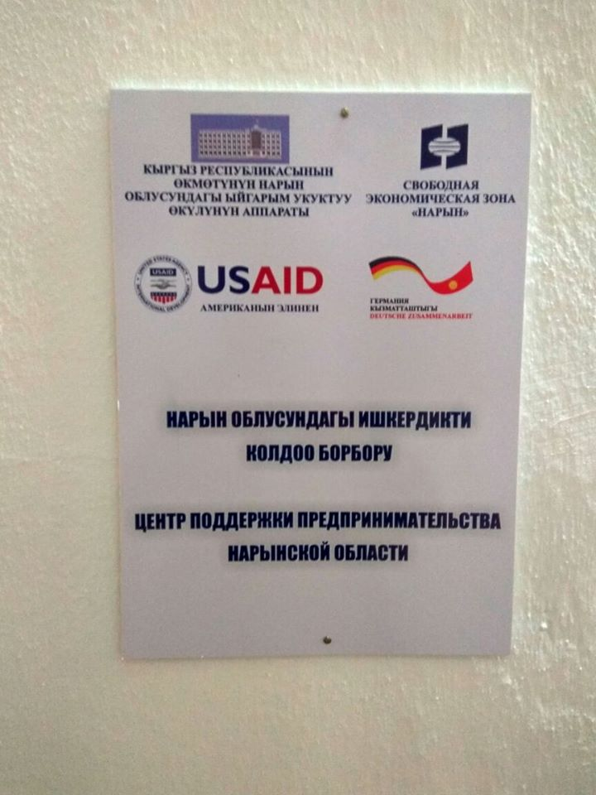
The Council's Secretariat established Regional Investment Councils in Naryn, Osh and Issyk-Kul regions to expand and strengthen regional public-private dialogue. An expert on regional public-private dialogue holds regular consultations with the regional councils' secretaries. Local specialists in Osh and Naryn Oblast were hired with the support of the USAID Business Development Initiative to strengthen regional institutions.
Meetings in regions are also held on a quarterly basis and representatives of regional business associations initiate the agenda of meetings. The main objective of local specialists' work is also to provide a continuous legal support to entrepreneurs and ensure constant communication with the Council at the national level. Main issues raised at the regional level are access to financial resources, creation of business associations, strengthening of public-private dialogue, creation of guarantee funds in the regions, creation of regional logistics centers, development of interregional trade, development of regional tourism, as well as barriers in development of production for export in regions. The Center for Business and Entrepreneurship Support was opened in the Free Economic Zone of Naryn in Naryn oblast with the support of the Secretariat of the Council and the financial support of GIZ and the USAID BGI project. At present, funds are being sought for a creation of such a center in Osh and Issyk-Kul oblasts.
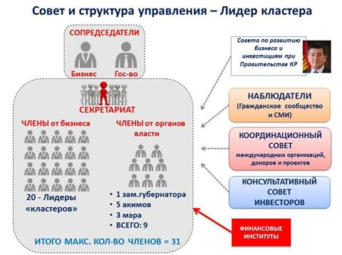
With an arrival of the new Plenipotentiary Representative of the Government of the Kyrgyz Republic in the Issyk-Kul region, the position of the Council was changed, and a new strategy for a development of the Issyk-Kul Council was created. The Secretariat of the Council for Business Development and Investment of Issyk-Kul oblast organized its work on a basis of the cluster approach in development of the region.
Cluster committees were set up under the Council in the following areas: meat and milk, tourism, medical and rehabilitation, fruit and berry, aquaculture and fish farming, beekeeping, renewable energy sources and a cluster of phyto technologies. The Investment Council provided a consultation in October 2016 to the Secretariat of the Issyk-Kul Council on Business and Investment Development under the Plenipotentiary Representative of Issyk-Kul Oblast. A joint meeting was held together with representatives of the Investment Council and with a International Finance Corporation's project on improving the investment climate, where IFC representatives expressed support for a specialist from the Secretariat who will work on developing agriculture in the Issyk-Kul region.
Prepared documents: Analytical materials and materials for conferences, trainings were developed.
Results: The level of influence of the Secretariat in expert circles and the business community is growing.

II. ENSURING PARTICICATION OF BUSINESS CIRCLES AND DONOR COMMUNITY IN THE DECISION-MAKING PROCESS

1.5. Activity 5. - Analytical support to a process of public-private dialogue

- Identification of agencies (for example, donors) that are present in the country and which can assist in analytical work on certain issues raised by the Council, as well as coordinating work with these agencies and other stakeholders in working groups.
In order to inform partners and IC members - representatives of international donor organizations, IC experts presented two components of IC activities at the regular meeting of the Consultative Council of Development Partners (CCDP): the regional development of PPD process and strengthening of interaction with the Jogorku Kenesh. Possible cooperation within the framework of projects and programs implemented by international development partners was discussed during the meeting.
In continuation of the presentation at CCDP meeting, the IC leadership held a meeting with the project on good governance, support for Parliamentarism component, implemented by the UK Department for International Development. Jeff Lilly, DFID, the Head of the Program of Cooperation with the Jogorku Kenesh, and Ruslan Murzalimov, the Coordinator of the program, met to discuss cooperation possibilities. The parties exchanged information during the meeting, and also reached an agreement on cooperation within the framework of activities to increase the capacity of MPs and improve PPD process. Additionally, a meeting was held with an expert on Parliamentarism, Ms. Sue Griffiths, the international consultant of the Program of Cooperation with the Jogorku Kenesh.
In continuation of the CCDP meeting, the IC expert met with representatives of the OSCE Center in Bishkek. The meeting was attended by: Eduardo Do Rossa, the Head of the Department of Economics and the Environment, Kalys Hasanova, National Program Coordinator, as well as Nurmat Toktomamatov, Project Manager, Systematic analysis of Regulation. As a result of the meeting, the IC will prepare a project proposal for consideration by the OSCE program for 2017.
An IC expert held a meeting with John Di Pirro - National Director and Kanat Zholdoshov - Program Director of the International Republican Institute (IRI). The IRI has been implementing its programs in Kyrgyzstan for over 10 years; the main directions are aimed at a development of the Institute of Parliamentarism and party building. Within the framework of increasing the capacity of Parliamentary factions, the IRI and IC agreed to hold joint activities to train MPs in the JK on fundamentals and principles of the PPD process.
The Secretariat of the Council together with other projects on improving the investment climate and business environment continues the work of the Working Group on donor's coordinating group in order to improve an investment climate and the business environment. Four meetings of the group were held in 2016.
The Secretariat of the Council informed participants about activities of the Council in the regions on January 28, 2016 at a meeting of group of donors involved in a development of the private sector in the office of the Council’s Secretariat. Representative of the Promotank company introduced interim results of a study on reducing social contributions. Due to a fact that this study was not completed, the representative of the company asked donor organizations to consider a possibility to allocate additional financial resources.
A meeting of the donor coordination group on private sector development was held at the office of the Council’s Secretariat on March 17, 2016. The participants of the group informed about latest activities carried out within the framework of projects aimed at improving the investment climate and business environment. Additionally, Mr. Cho, the president of the company GTS, informed about an upcoming regional conference and training seminar "Logistics and Supply Chain Management", which will be held on May 18-20, 2016 in City Hotel, Bishkek. A representative of the Ministry of Economy of the Kyrgyz Republic informed about an implementation of the export development plan for 2015-2017 and specified a need to update this plan at the present time. A representative of GTZ confirmed their support in updating the plan.
Results of the USAID Project on business development in the textile industry were presented at a meeting of the group on June 28, 2016; participants discussed results of the trade development program of the World Trade Center.
K.K. Kulmatov, the Chairman of the Russian-Kyrgyz Development Fund (RKDF) Board presented on October 27, 2016 at an invitation of members of the group and informed about projects financed by RKDF. Further on, R. Toimbetov, the representative of the State Inspectorate for Veterinary and Phytosanitary Security under the Government of the Kyrgyz Republic informed about laboratories and its technical equipment. M.G. Halitov, the Deputy Director of the State Agency for Local Self-Government and Interethnic Relations under the Government of the Kyrgyz Republic presented on a third issue - the Mountain Cluster. A creation of the Mountain Cluster was initiated at one of the meetings of the Council for Business Development and Investment under the Government of the Kyrgyz Republic. At present, the working group has developed a draft law and needs technical assistance to finalize this law. The last issue discussed was the GIZ project "Regional Trade Support Program in Central Asia", which informed the participants about an establishment of the National Committee for Trade Facilitation.
In preparation for meetings of the Council, Secretariat’s staff actively cooperates with all projects aimed at improving the investment climate and business environment, in such areas as optimization of regulatory framework for business, tax administration.
The Asian Development Bank continues to support development of regulations in support of an implementation of the Law of the Kyrgyz Republic "On Public-Private Partnerships".
The USAID Business Development Initiative Project supported strengthening of regional investment councils in Osh and Naryn and provided funding to support two local specialists in these areas.
The Secretariat of the Council carried out a series of studies and round tables with an assistance of international projects to implement decisions of the Council. All round tables and conferences are mentioned in the Activity - 3.
In addition, in 2007-2013 expert support was provided to the EU (3 experts on customs, tax and IT issues), ADB (1 coordinator-expert), JICA (1 expert on the mining sector), IFC project on improving the investment climate (1 expert on agriculture) and the project USAID REFORMA (1 expert on public-private dialogue).

Prepared documents: An updated map of donor technical assistance in areas of business environment and investment climate, which created a basis for joint work of the Secretariat and the donor community.
Consultations are held on an ongoing basis with donors to increase their participation in the activities of the Secretariat.
Results: Areas in which donor assistance is being provided are identified and this assistance is used in activities of the Council. The research conducted by donors became a basis for a subsequent development of the private sector development program. A participation of donors in supporting the Secretariat is increasing. The working group on donor's coordinating group in order to improve an investment climate and the business environment continues to operate on a quarterly basis.

1.6. Activity 6 - Improving a process of public-private dialogue

- Development of proposals on relevant structure and organization of the work of the Council.
- Preparation of practical recommendations on regulatory conditions, institutional improvements, and / or structures to be established and / or strengthened.
Changes were made in 2016 to the Government of the Kyrgyz Republic's Resolution "On Establishment of the Business Development and Investment Council under the Government of the Kyrgyz Republic" from August 5, 2010 based on consultations of EBRD with the business community on a structure and organization of the Council.
Steps taken:

- Identification of key public and private sector participants in consultation with the EBRD's local office management as candidates for membership in the Council.
Steps taken:
In determining the structure of the Council, the principles of public-private dialogue were taken into account - the structure of PPD should be manageable (a number of participants is minimal but representative), balanced (equal participation of the parties), and participation of leaders from both sides (state and business).
Experts of the Council's Secretariat carried out work to change the Government's resolution on a creation of the Council based on results of consultation of EBRD with the business community and to strengthen the public-private dialogue. As a result of discussions with the Parliament of the Kyrgyz Republic and the Office of the President of the Kyrgyz Republic, 3 deputies representing the Committee on Economic and Fiscal Policy, the Head of the Department for Financial and Economic Analysis and Monitoring of Development under the Office of the President of the Kyrgyz Republic were included in the Council. Corresponding amendments were introduced on May 17, 2016 No. 261 in existing Government Decision on the establishment of the Council.
According to a Provision on the Council, business-associated structures submit candidates for membership to the Secretary of the Council. It should be noted that there is no strictly regulated quantitative limitation in Council's membership for business associations.
Members of the Council - representatives of business-associated structures, directly involved in preparation of issues submitted for consideration by the Council, as well as interested in resolving these raised issues participate at each meeting of the Council.
Thus, on the one hand, a more extended number of business representatives can participate in the activities of the Council, but on the other hand, they must actively participate in activities of the Council and promote their interests; a possibility of their passive participation is excluded.
At present, 56 business associations are members of the Council.
- Determination of members of the Council for Business Development and Investment from International Institutions
Steps taken:
According to the Council's Provision, international donor organizations select Council members from international institutions at a donor council for every two or three meetings of the Council. Members of the Council from donor organizations are currently representatives of the Asian Development Bank and the Embassy of the Federal Republic of Germany in the Kyrgyz Republic.
Prepared documents: The Secretariat receives minutes of Donor Council meetings on members from the donor community. The Secretariat conducts extensive consultations on participation of members from business associations in specific meetings, a participation of these members is reflected in minutes of the meeting of the council.
Results: democratic procedures for participation at the council's meeting were introduced; participation of representatives from business associations was not restricted.

1.7. Activity 7 - Implementing decisions of the Council

- Preparation of minutes from the meeting of the Council for approval by members of the Council and implementation of activities outlined in the discussions.

Meetings of the Council are an important part of the Council's activities, the main purpose of which is to define an action plan for state bodies and the private sector in a course of implementation of the investment policy. Decisions of the Council are taken by a majority of votes on the issues under consideration and are drawn up in a form of protocols with developed proposals and recommendations to the Government of the Kyrgyz Republic and other state bodies tasked with improving the business environment and investment climate, and with effectively attracting and using foreign investments.
As part of implementing decisions of the Council, the following regulatory legal acts of the Kyrgyz Republic were adopted:

Decisions of the Government of the Kyrgyz Republic:

- On introduction of amendments to some decisions of the Government of the Kyrgyz Republic (a composition of the Council was supplemented by the deputies of the Jogorku Kenesh of the KR, members of the Committee on Economic and Fiscal Policy of the Jogorku Kenesh of the KR and the Department Head for financial and economic analysis and monitoring of development under the Office of the President of the KR) from May 17, 2016, No. 261.
- "On amendments to the Resolution of the Government of the Kyrgyz Republic" On Approval of criteria for assessing a risk level in conducting a business activity" from February 18, 2012, No. 108 and from March 31, 2016, No. 167.
- "On approval of Unified Tax Declaration forms and a procedure for their completion" from April 30, 2016, No. 228.
- "On introducing amendments to the Resolution of the Government of the Kyrgyz Republic "On the approval of forms for tax reporting on indirect taxes, applications for import of goods and payment of indirect taxes, notification/form of the forthcoming receipt of excisable goods or import (export) of goods and procedures for filling such forms" " from April 22, 2015, No. 234 and June 16, 2016, No. 326.
- On approval of the Concept for Development of the Jewelry Industry of the Kyrgyz Republic until 2018, from July 11, 2016, No. 381.
- "On amending the Resolution of the Government of the Kyrgyz Republic "On Measures for an implementation of a mechanism for the use of cash registers with online data transmission function" from June 15, 2016, No. 324" and from November 19, 2016, No. 633 (postponement of introduction of online KKM mode).
- On approval of the Public-Private Partnership Development Program in the Kyrgyz Republic for 2016-2021from June 16, 2016, No. 327.
- On a Program for Improving the Financial Literacy of the Population of the Kyrgyz Republic for 2016-2020, Decree No. 319 from June 15, 2016
- On approval of the pilot project program for development of the dairy industry in the Issyk-Kul region for 2016-2019, the Government's order from June 20, 2016, No. 279-r.

Laws of the Kyrgyz Republic

- Law from August 12, 2016, No. 167 "On Amending the Tax Code of the Kyrgyz Republic". The main objective of the law is to improve an administration of the value-added tax by introducing electronic assignment of series and numbers to VAT invoices for taxpayers and cancellation of strict VAT reporting forms. Innovation reduces unnecessary temporary and material costs for both taxpayers and tax authorities in obtaining, keeping records and using paper invoices, also reduces excessive reporting on a use of invoice forms and minimizes errors that occur when recording paper forms of invoices.

Results: A mechanism has been created to ensure an implementation of decisions of the Council and adopted by the normative legal acts, implementing decisions of the Council.

III. Current activities of the Secretariat to achieve the set goals

1.8. Activity 8 - Managing process of public-private dialogue

- Manage a process of dialogue and current activities of the Council from the beginning to the end of the assignment.

Experts of the Secretariat in 2016 worked in accordance with the previously developed process of monitoring of decisions of previous meetings of the Council. The earlier introduced norms, according to which the recommendation of the Council is considered completed and only in a case of solving this problem based on merits and not on formal grounds, showed its effectiveness. The Prime Minister, the Chairman of the Council instructs the state bodies (responsible executors) to provide a monthly report to the Secretariat of the Council for a continuous process of monitoring of the Council's decisions. In turn, the Secretariat of the Council informs the Prime Minister of the Kyrgyz Republic about an state of implementation of decisions of the Council. In case of delays or non-execution of decisions by responsible ministries and departments, the Secretariat's experts hold meetings with business associations and heads of ministries and departments responsible for implementing decisions.
In connection with a change in a composition of the Council, the experts of the Secretariat also inform members of the Council, deputies of the Parliament of the Kyrgyz Republic and the head of the financial analysis department under the Office of the President of the Kyrgyz Republic about forthcoming events of the Council.
Experts of the Secretariat on a regular basis inform business associations about forthcoming amendments to normative legal acts and ensure discussion of drafts of normative legal acts.
Experts of the Secretariat are also involved in discussing an agenda of meetings of regional councils, providing expert support in a development of issues initiated by regional business associations, drawing up protocols of regional councils.
The Secretary of the Council has participated in working meetings since September 2016 chaired by O.M, Pankratov, the Vice Prime Minister, on an execution of decisions from meetings of the Investment Council and on discussion of forthcoming meetings of the Council.
Experts of the Secretariat organized more than 20 working meetings with representatives of business associations and heads of ministries and departments responsible for implementing decisions to discuss issues of upcoming meetings of the Council and monitoring of previous meetings of the Council.
Experts of the Secretariat take part in preparing theses for the Prime Minister's speeches at the meeting of the Council.
Prepared Documents: Secretariat's Work Plans and reports on its implementation, minutes of meetings of working and expert groups.
Results: The current work of the Secretariat has been established and improved.

1.9. Activity 9 - Capacity development of the Secretariat

- Participation in selection of Secretariat's staff
The staffing of the Secretariat of the Council, financed by the EBRD, was increased by two positions in 2016, which were established in consultation with the business community: an expert on relations with the Parliament and a regional PPD expert.
Also, in connection with a transition to another job of an expert in economy and finance, a competitive selection was held for this position.
4 additional experts from business associations in such areas as: construction industry, tax issues, finances, and deregulation of the economy, also support the activity of the Secretariat of the Council.
Prepared documents: Memorandums on cooperation with business associations and Terms of Reference for an expert.
Results: The Secretariat was able to expand coverage of industry activities through an expertise provided by involved experts.

- Capacity building of Secretariat staff on a basis of ongoing activities and participation in regional seminars and conferences held by various organizations (eg EBRD, World Bank, bilateral organizations)

T. Shakeyev, an expert of the Secretariat, on April 18, 2016 took part in a seminar to raise awareness among government officials about a concept of public private partnership, study international experience, discuss key trends and priority sectors of PPP development, and define a further strategy for PPP development in the Kyrgyz Republic. The Ministry of Economy with a support of the Asian Development Bank organized the seminar.
T. Shakeev, an expert of the Secretariat, attended the Seventh International Scientific and Practical Conference on Administrative Law "Discretion and Valuation Concepts in Administrative Law" on November 3-4, 2016. This conference, which has become traditional in Central Asia, is one of most important conferences in the area of public law and serves as a communication platform for lawyers from the post-Soviet space and European countries to discuss prospects for a development of the administrative law. The conference was organized with a support of the Supreme Court and the Ministry of Justice of the Kyrgyz Republic and GIZ Program "Promoting legal statehood in the countries of Central Asia" in conjunction with the project of the European Union "Promoting the Rule of Law in the Kyrgyz Republic".

Results: A skill level of the Secretariat's staff is growing. A role of the Secretariat in improving the investment climate is increasing.

1.10. Activity 10 - Reports of the Secretariat

- Provision of monthly financial reports to the EBRD office and relevant EBRD staff at the head office in London

Steps taken:
Financial reports are provided monthly to the EBRD office in London and to the EBRD office in the Kyrgyz Republic.
This report covers activities of the Secretariat from January to December 2016.
Prepared documents: Annual reports, monthly financial reports
Results: The Secretariat's reporting mechanism to the Bank is sustainably operating.

2. MONITORING

2.1. Internal monitoring
The Secretariat of the Council pays much attention to monitoring of implementation of the Council's decisions. A monitoring plan was developed for the Council's decisions to improve an implementation of decisions adopted at the Council's meetings. Such plan, based on instructions from the Government of the Kyrgyz Republic, obliges the responsible ministries and departments to report every three weeks on an implementation of the Council's decisions. Also, in order to improve monitoring of decisions, the Secretariat of the Council constantly informs all interested parties about a progress in implementing decisions of the Council at meetings to discuss minutes from the meetings of the Council.

3. EVALUATION OF RESULTS OF ACTIVITIES

3.1. Direct performance evaluation
About 25 roundtables, seminars, conferences with the participation of state structures, business and international partners were organized and conducted in 2016, with an assistance of the Secretariat of the Council.
7 interdepartmental and sectorial working groups with business participation were established based on the Council's decision. In general, 37 working groups were created during an existence of the Council to resolve various issues brought up in decisions from the Council's meetings.
More than 12 normative legal acts, strategies and concepts on decisions of the Council with the participation of the Secretariat of the Council have been prepared and adopted. More than 73 normative legal acts with assistance of the Council for over 10 years were adopted based on decisions of the Council.
According to the system of performance assessment indicators introduced by the Secretariat in 2013, the percentage of completed initiatives by business associations to the number of started initiatives by the business community in 7 years is a quantitative indicator, which characterizes effectiveness of work of the Council, including quality of drafting decisions and monitoring their implementation by the Secretariat.
Table 1 shows the total number of initiatives raised at meetings of the Council and the number of implemented decisions. At the same time, the performance is given by years.

Table 1. Number of raised and implemented IC initiatives
Initiatives | Total | Implementation |  |  |  |  |  |  |  |  |  | Completed | % of completion
 |  | 2007 | 2008 | 2009 | 2010 | 2011 | 2012 | 2013 | 2014 | 2015 | 2016
2007 | 10 | 5 | 3 | 1 |  |  |  |  |  |  |  | 9 | 90,0
2008 | 16 |  | 11 | 5 |  |  |  |  |  |  |  | 16 | 100,0
2009 | 12 |  |  | 7 |  | 2 |  |  |  |  |  | 9 | 75,0
2010 | 10 |  |  |  | 5 |  | 1 | 1 |  |  |  | 7 | 60,0
2011 | 17 |  |  |  |  | 8 | 2 | 2 |  |  |  | 12 | 70,6
2012 | 14 |  |  |  |  |  | 10 | 3 |  |  |  | 13 | 85,7
2013 | 17 |  |  |  |  |  |  | 8 | 5 |  |  | 13 | 76,4
2014 | 19 |  |  |  |  |  |  |  | 12 | 3 |  | 15 | 78,9
2015 | 19 |  |  |  |  |  |  |  |  | 13 | 3 | 16 | 84,2
2016 | 12 |  |  |  |  |  |  |  |  |  | 10 | 10 | 83,3
ИТОГО | 144 |  |  |  |  |  |  |  |  |  |  | 120 | 83,3

Since most of decisions from 2016 meetings are in an implementation stage, the Secretariat suggests to not to take them into account in this report. In general, an implementation of initiatives from 2007 to 2016 is at 83.3% level. That is, every four of five initiatives receive the necessary resolution. This is higher than that established by the target monitoring indicator for implementation of decisions, which is equal to 75%.
As follows from this Table, 16.7% of all decisions were not executed, but the Secretariat continues to monitor an implementation of all decisions and discusses various options for completing outstanding issues with both the business community and the Government with a view to promote final decision-making process on these issues.

CONCLUSION

Over the ten years of its work, the Council has established itself as an effective institution for dialogue between the state and business, and made a significant impact in improving the business environment in the Kyrgyz Republic. In all, 56 business associations are currently members of the Council, uniting more than 2,000 companies and enterprises in various sectors of the economy. The development level of the business community has grown extensively over the years of the Council's work, as noted by observers. The Secretariat of the Council succeeded in consolidating business associations due to dynamic and flexible responses to the requests of the business community. An important activity of the Secretariat of the Council is an expansion of activities in regions to establish a dialogue between local authorities and the business community. A development of regional dialogue platforms strengthens a potential of the local business community, fosters creation of business associations, helps to establish feedback loop between the government and the local community.
The Secretariat will continue its work to strengthen business associations and expand their representation as members of the Council from the business community, to participate in the PPD both at the national and regional level, and to perform analytical work for business associations through an involvement of specialists and provision of training.
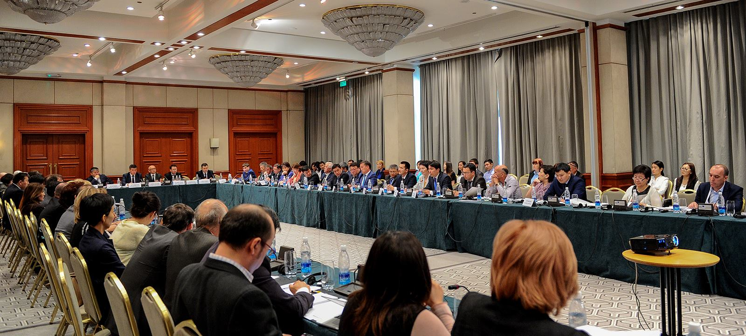
One of the main factors in effective work of the Secretariat is a well-established procedure for organizing PPD, primarily reporting to the business community on an implementation of the decisions of the Council. The Secretariat of the Council will continue to monitor previously adopted decisions of the Council and will promote current business requests, demonstrating openness of the PPD platform.
The Secretariat began a process of interaction with the country's parliament to expand PPD capabilities, involving parliamentarians in the Council's activities, and organizing interaction between parliamentarians and the business community on draft laws that affect the business environment.
The Secretariat of the Council will strengthen its work with international partners in order to deepen their involvement in supporting the business community, especially in the regions of the country.

Appendices

PROTOCOL  of a meeting of the Council for Business Development and Investment under the Government of Kyrgyz Republic | Кыргыз Республикасынын Өкмөтүнө караштуу бизнести өнүктүрүү жана инвестициялар боюнча кеңештин отурумунун  ПРОТОКОЛУ

February 25, 2016  14:00-17:00 | Bishkek  Hyatt Hotel

Participants:
In accordance with a list of participants attached to the current protocol

1. On an execution of decisions of the meeting of the Council for Business Development and Investment under the Government of the Kyrgyz Republic from November 25, 2015
(Koichumanov, Sariev)

After listening to a speech by T. G. Koichumanov, the Secretary of the Council for Business Development and Investment under the Government of the Kyrgyz Republic on execution of decisions of a meeting of the Council for Business Development and Investment under the Government of the Kyrgyz Republic from November 25, 2015, the Council decided to recommend that:

1.1. State agency of anti-monopoly regulation under the Government of the Kyrgyz Republic jointly with the concerned government agencies, domestic shipping companies, local importers and business associations within a month is to carry out a comprehensive analysis of causes for a rising cost of delivery.

1.2. Pankratov O.M., Vice Prime Minister of the Kyrgyz Republic within a week is to hold a meeting with a participation of the Ministry of Economy of the Kyrgyz Republic, the Ministry of Finance and the State Tax Service under the Government of the Kyrgyz Republic in order to consider proposals of the International Business Council on improving activities of the Methodological Council on a coordination of fiscal policy under the Ministry of economy of the Kyrgyz Republic.

1.3. Secretariat of the Council for Business Development and Investment under the Government of the Kyrgyz Republic is to provide information at the next meeting of the Council about unexecuted Council’s decisions from meetings in 2015.

2. On execution of anti-crisis measures in 2015 and 2016 (anti-crisis part of the Action plan of the Government of the Kyrgyz Republic "Stability, credibility and new opportunities for 2016")
(Imanaliev, Azhykulov, Sharsheev, Ponomarev, Abakirov, Temiraliev, Nurmatov, Uskenbaeva, Abakirov, Faridinova, Karymshakova, Kydyrbaev, Osmonoliyev, Becker, Pankratov, Doolotalieva, Sariev )

After listening to a speech by D. Imanaliev, Deputy Minister of Economy of the Kyrgyz Republic and taking into account a discussion that followed, the Council’s members decided to recommend:

2.1. Ministry of Economy of the Kyrgyz Republic within one day is to consider proposals for additional anti-crisis measures, voiced by representatives of business associations and pass onto the Government’s Office of the Kyrgyz Republic for consideration at a meeting of the Government of the Kyrgyz Republic.

3. On issues of export-import operations in a time of enterance of the Kyrgyz Republic onto the EAEC
(Uskenbaeva, Matkerim uulu, Abdyldaev, Mamyrkanov, Sariev )

After listening to speeches by Uskenbaeva G., President of the Association of suppliers and distributors, Talantbek Matkerim uulu, Chairman of the Subcommittee on Transportation of the Chamber of Commerce and Industry of the Kyrgyz Republic, Abdyldaev E., Minister of Foreign Affairs of the Kyrgyz Republic, Mamyrkanov E., Deputy Minister of Transportation and Communications of the Kyrgyz Republic and taking into account a discussion that followed, the Council’s members decided to recommend:

3.1. Ministry of Economy of the Kyrgyz Republic within two weeks is to develop and submit to the Government Office of the Kyrgyz Republic a draft order for Eurasian Economic Commission (EEC) on an inclusion in an agenda of the meeting of the EEC Board of an issue of transit of goods from the Republic of Turkey and the Republic of Ukraine to the Kyrgyz Republic.
3.2. Government Office of the Kyrgyz Republic within a week is to prepare draft letters addressed to Russian and Kazakh sides on issues of transit of goods to the Kyrgyz Republic.

3.3. Ministry of Transportation and Communications of the Kyrgyz Republic within a month is to submit to the Chamber of Commerce of the Kyrgyz Republic documents on active and alternate routes of delivery of goods to the Kyrgyz Republic, stating a distance, border crossings and possible risks (timing and material).
3.4. Ministry of Foreign Affairs of the Kyrgyz Republic is to consider and study an issue of a possibility of accelerating issuance of visas to Iran and Turkmenistan on an expedited basis for cargo carriers of the Kyrgyz Republic, as well as persons accompanying such cargo. Inform the Secretariat of the Council about results.

3.5. Ministry of Economy of the Kyrgyz Republic, the State Tax Service under the Government of the Kyrgyz Republic together with the Association of suppliers within three months:
- To develop proposals to amend the Resolution of the Government of the Kyrgyz Republic "On approval of a list of documents for export and import of goods, works and services in the Eurasian Economic Union" from July 31, 2015 № 550 and other normative legal acts that reduce a number of required documentation affixed to an application for import of goods and payment of indirect taxes, simplifying an application process, and to submit to the Office of the Government of the Kyrgyz Republic;
- Simplify indirect taxes reporting form;
- Merge an indirect taxes report with VAT report for VAT payers.

3.6. To recommend that Digital Management Centre of the Government of the Kyrgyz Republic with a participation of representatives of the business community within a month to develop and submit to the Government Office of the Kyrgyz Republic a Draft Action Plan, ensuring an introduction of a single (unified) digital signature for business entities when interacting with public authorities and private companies that provide access to electronic databases and services.

4. On issues of further development of the High-Tech Park
(Abakirov, Sariev)

After listening to speeches by A. Abakirov, Chairman of the Kyrgyz Association of Software Development and Service and taking into account a discussion that followed, the Council’s members decided to recommend:

4.1. Ministry of Transportation and Communications of the Kyrgyz Republic jointly with the State Property Management Fund under the Government of the Kyrgyz Republic within one month is to consider a proposal of the Kyrgyz Association of Software Development and Services related to an allocation of premises for the High-Tech Park. Propose a decision on this issue to the Office of Government of the Kyrgyz Republic after a review.

Entrust a control over an implementation of the above decisions to the relevant departments of the Government Office of the Kyrgyz Republic.

Prime Minister of KR,
Chairman of the Council
of Business Development and Investment
under the Government of KR T. A. Sariev

Secretary of the Council
of Business Development and Investment
under the Government of KR T. Dj. Koichumanov

LIST
Of participants from the meeting of the Council for Business Development and Investment under the Government of the Kyrgyz Republic from February 25, 2016

Sariev Temir Argembaevich | - | Prime Minister of the Kyrgyz Republic, Chairman of the Council
Members of the Council:
Pankratov Oleg Mikhailovich | - | Vice Prime Minister of the Kyrgyz Republic;
Tyumenbaev Bakkeldi Rakhimovich | - | Deputy Minister of Economy of the Kyrgyz Republic;
Imanaliev Daniyar Sharshenbekovich | - | Deputy Minister of Economy of the Kyrgyz Republic;
Uskenbaeva Gulnara Turarovna | - | President of Association of manufacturers and distributors of the KR;
Talantbek Matkerim uulu | - | Chairman of the Subcommittee on Transportation of Chamber of Commerce and Industry of the Kyrgyz Republic;
Komissarov Vladimir Anatolievich | - | President of the Silk Road Tourism Association
Azhykulov Temirbek Nazarbekovich | - | Executive Director of IBC;
Abakirov Azis Zhumabekovich | - | Chairman of the Kyrgyz Association of Software Development and Services;
Temiraliev Umbriel Temiralievich | - | Chairman of JIA Business Association;
Ponomarev Sergey Vasilevich | - | President of the Association of markets, trade and services;
Dolotalieva Damira Temirbekovna | - | Chairman of the Trade Union of Kyrgyzstan trade;
Sharsheev Iskender Sherimbekovich | - | Executive director of the Association of Foreign Investors;
Malik Ajdar Abakirov Baryktabasovich | - | Chairman of the Association of guarantee funds;
Rustam Nurmatov | - | Member of the Chamber of Commerce of the Kyrgyz Republic;
Koichumanov Talaibek Djumashevich | - | Secretary of the Council, Head of Secretariat of the Council.
Invited parties from Jogorku Kenesh (Parliament) of the Kyrgyz Republic
Asylbaeva Gyulshat Kadirovna | - | Deputy of the Jogorku Kenesh of the Kyrgyz Republic;
Bekeshev Dastan Dalabayevich | - | Deputy of the Jogorku Kenesh of the Kyrgyz Republic;
Invited parties from the Government of the Kyrgyz Republic
Abdyldaev Erlan Bekeshovich | - | Minister of Foreign Affairs of the Kyrgyz Republic;
Mambetalieva Jyldyz Zheenbaevna | - | Minister of Justice of the Kyrgyz Republic;
Bekboev Turdunazir Bekboevich | - | Minister of Agriculture and Land Reclamation of the Kyrgyz Republic;
Osmonov Zamirbek Babakulovich | - | Chairman of the State Tax Service under the Government of the Kyrgyz Republic;
Zhunusov Adamkul Orokeevich | - | Chairman of the State Customs Service under the Government of the Kyrgyz Republic;
Sulaymanov Azamat Talapbekovich | - | First Deputy Chairman of the State Customs Service under the Government of the Kyrgyz Republic;
Abulgaziev Muhammedkaly Dyushekeevich | - | Chairman of the Social Fund of the Kyrgyz Republic;
Turganbaev Melis Toktomambetovich | - | Minister of Internal Affairs of the Kyrgyz Republic;
Bayamanova Zuura Eduardovna | - | State Secretary of the Ministry of Finance of the Kyrgyz Republic;
Mamyrkanov Ernis Tursunkadyrovich | - | Deputy Minister of Transportation and Communications of the Kyrgyz Republic;
Murataliev Azizbek Duyshenovich | - | The Chief Expert of fiscal policy department and financial analysis of the Ministry of Education of the Kyrgyz Republic;
Suyumbaeva Paiza Usenbaevna | - | State Secretary of the Ministry of Health of the Kyrgyz Republic;
Zhamankulov Azamat Kaparovich | - | Deputy Minister-Director of the Department of Tourism under the Ministry of Culture, Information and Tourism of the Kyrgyz Republic;
Atadjanov Sabir Sadykdzhanovich | - | Director of the State Environmental Protection Agency and Forestry under the Government of the Kyrgyz Republic;
Kazakov Bolsunbek Kumushbekovich | - | Director of the State Antimonopoly Regulation Agency under the Government of the Kyrgyz Republic;
Mukanbetov Sanjar Turdukozhoevich | - | Chairman of the State Service of regulation and supervision of financial markets under the Government of the Kyrgyz Republic;
Sheripov Nurlan Turganbekovich | - | State Secretary of the State Registration Service under the Government of the Kyrgyz Republic;
Zhyltyrov Bakyt Zhanybaevich | - | First Deputy Chairman of the State Border Service of the Kyrgyz Republic;
Kadyrkulov Almazbek Apandievich | - | Chairman of the State Property Fund of the Kyrgyz Republic;
Zhumakanov Kalysbek Turatbekovich | - | Chairman of the State veterinary and phytosanitary safety inspection under the Government of the Kyrgyz Republic;
Nurkulova Gulnara Zhoroevna | - | Deputy Chairman of the Board of JSC "State Mortgage Company"
Kasymov Jyrgalbek Turatbekovich | - | Executive Director of the Deposit Protection Agency of the Kyrgyz Republic;
Usenbaev Azamat Asangulovich | - | Deputy General Director of the State Enterprise "Single Window Centre in an foreign trade area" under the Ministry of Economy of the Kyrgyz Republic;
Abdygulov Tolkunbek Sagynbekovich | - | Chairman of the National Bank of the Kyrgyz Republic;
Asrandiev Erkin Shamshudinovich | - | Chairman of the Board of OJSC "Aiyl Bank";
Kudyakov Oleg Amirovich | - | Member of the Board of the Russian-Kyrgyz Development Fund;
Baijumanov Dzhambulat Bayzhumanovich | - | First Deputy Chairman of the National Statistical Committee of the Kyrgyz Republic;
Baiterekov Taalai Alymbekovich | - | Director of the Center of digital management of the Government of the Kyrgyz Republic;  Republic.
Adilbek uulu Shumkarbek | - | Deputy Director of the Investment Promotion Agency under the Ministry of Economy of the Kyrgyz Republic;
Eshimbekov Askar Erkinovich | - | General Director of JSC "Severelectro";
Kozhomberdieva Akylai Turarovna | - | Head of entrepreneurship policy and FEZ sector of the Ministry of Economy of the Kyrgyz Republic;
Baydoletov Nuradil | - | Head of the Strategic Planning Department of the Ministry of Economy of the Kyrgyz Republic;
Arunova Indira | - | Head of Regulatory Reform Department;
Sultanov Talant Isakovich | - | Director of the National Institute for Strategic Studies of the Kyrgyz Republic.
Invited parties from the Office of the President of the Kyrgyz Republic:
Kadyraliyev Aibek Dzhumabaevich | - | Head of Department of financial and economic analysis and monitoring of the Office of the President of the Kyrgyz Republic.
Invited parties from the Office of the Government of the Kyrgyz Republic:
Mukambetov Murat Kartaybekovich | - | First Deputy Chief of Staff of the Government of the Kyrgyz Republic
Chuikov Nikolai Alexeevich | - | Head of Department of Economy and Investment of the Government Office of the Kyrgyz Republic (hereinafter -GOKR);
Azhigulova Zamira Bayseitovna | - | Head of Social Development Department of GOKR;
Oskombaev Askar Kubanychbekovich | - | Advisor to Prime Minister;
Djamankulov Marat Turgunbaevich | - | Head of Legal Support Department of GOKR;
Aaliev Aziz Kubanychbekovich | - | Head of financial and credit policy department of GOKR;
Zheenaliev Almaz Zheenalievich | - | Head of agriculture and ecology department of GOKR;
Ubaliev Eldiyar Mamatzhanovich | - | Head of the Department of Transportation, Construction and Communications of GOKR;
Jalilov Almazbek Zhalilovich | - | Expert of the department of economy and investment of GOKR
Invited parties from business associations and donor organizations
Kim Tatyana Mihailovna | - | Chairman of board of «The Chamber of Tax Consultants»
Davletaliev Amangeldy Satarovich | - | Senior vice president of the Chamber of Commerce and Industry of the Kyrgyz Republic;
Osmonoliyev Rustam Mirelevich | - | President of the Poultry Association of the Kyrgyz Republic;
Karymshakova Gulmira Beksultanovna | - | Executive Director of the Center for workforce development;
Zhokunov Nurgazy Duyshenkulovich | - | Director of Quadra Group consulting company;
Sarbashev Atay Sardarbekovich | - | Deputy Director of Quadra Group consulting company;
Kopbaev Kanat Azamatovich | - | Deputy Director of Quadra Group consulting company;
Turdubekov Ulukbek Baktybekovich | - | Lawyer, IBC;
Stephan Becher | - | Chairman of the IBC Committee on Tourism;
Ruslan Akmatbek | - | Executive director of JIA Business Association;
Abakirov Eldar Kurmanbekovich | - | Member of JIA business association;
Bazarbaev Jyldyzbek | - | Member of JIA business association;
Abdullayev Narbek | - | Chairman of the Committee for Construction of JIA Business Association;
Akmatov Urmat | - | Chairman of Committee on agriculture of JIA Business Association;
Temirlan Sarlykbek uulu | - | Board member of JIA business association;
Chingiz Esengul uulu | - | Member of JIA business association;
Abdraev Anvar Karikeevich | - | President of the Union of Banks of Kyrgyzstan;
Karabanov Gennadiy Nikolaevich | - | Executive Director of the Economic Chamber Association;
Faridinova Burul Faridinovna | - | Executive Director of the BBC;
Niyazbekov Temir Karypbaevich | - | Executive director of the Association of International automobile freight carriers of the Kyrgyz Republic;
Janybekova Reina | - | Member of the IBC;
Shekenov Adisbek Abdykulovich | - | Lawyer of JIA Association;
Sharapov Dmitriy Vladimirovich | - | Executive Director of the Kyrgyz-Russian Association -  New economic initiatives;
Ivchenko Maksim Petrovich | - | Member of the Board of the Kyrgyz-Russian Association -  New economic initiatives;
Gulnura Janybaeva | - | Deputy Head of the USAID “Business Growth Initiative” Project;
Dilyara Ishalina |  | Project Manager on taxation of the USAID “Business Growth Initiative” Project;
Raisa Ermakova |  | Chief Advisor on legal matters of the USAID “Business Growth Initiative” Project;
Asel Uzagalieva | - | Coordinator of NaWi/GIZ;
Ellen Kramer | - | Program Manager of NaWi / GIZ;
Ian Meyer | - | GIZ Trade Project.

Кыргыз Республикасынын Өкмөтүнө караштуу бизнести өнүктүрүү жана инвестициялар боюнча кеңештин отурумунун  Протоколу | PROTOCOL  of a meeting of the Council for Business Development and Investment under the Government of Kyrgyz Republic

№ 16-48 from May 30, 2016

11.00-12.30 | Bishkek  Hyatt Hotel

Chairman: | Prime Minister of the Kyrgyz Republic Jeenbekov S.Sh
Present:
From ministries and agencies | Novikov A.O., Kasymaliev A.A., Mambetalieva Zh.Zh, Osmonov Z.B., Sulaymanov A.T., Aydarov Z.K.,  Rustamov A.A., Kadyrkulov A.A.  Saparaliyev A.A., Sydykov D.B.,  Choduev E.U., Kutueva A.B.,  Akmatov K.B., Borobaev C.N,  Toktoshev A.C., Pakirov I.N.
from the Office of the President of the Kyrgyz Republic | Kadyraliev A. Zh.,
From the Office of the Government of the Kyrgyz Republic | Umetaliev S.B., Chuikov N.A.,  Jalilov A. Zh.
From business associations and donor organizations | Sydykov A.K., Sharshekeev M.D.,  Kydyrbaev U.A., Temiraliev U.T.,  Uskenbaeva G.T., Alimjanova, D.I.,  Kojchumanov T.Zh, Galieva Zh.U.,  Kim T.M., Shabdanaliev T., Tursuniyazov A., Musuraliev N.Zh., Ruslan A.  Gluhovskih V.V., Babayev R.Zh.,  Geletyuk İ.D., Yusupov D. Zh.,  Abdullayev N.M., Omurbekov B.,  Raimkulova Zh.A., Sharshembaeva E.,  Mambetalieva A., Niyazov T.N.  Ismailov E.M., Kojanov B, Tuguntaev G., Suranaliev E., Tentiev A., Tentieva A. KomissarovV.A., Abakirov A. Zh., Ponomarev S.V., Dzhekshenkulov B., Imay S., Doolbekova A. Oberhuber D., Djanybaeva G.

- On execution of decisions of the Council for Business Development and Investment under the Government of the Kyrgyz Republic from February 25, 2016
(Koychumanov, Borombaeva, Uskenbaeva, Sazbakov, Chuikov, Jeenbekov)

After listening to a speech by T. Koichumanov, the Secretary of the Council for Business Development and Investment under the Government of the Kyrgyz Republic on execution of decisions of a meeting of the Council for Business Development and Investment under the Government of the Kyrgyz Republic from February 25, 2016 and decisions of the Council from 2015, the Council decided to recommend that:

  - The Council's Secretariat to extend a deadline until July 1, 2016 for a provision of information by the State Tax Service under the Government of the Kyrgyz Republic on a possibility of simplifying reporting forms of indirect taxes.

  - State Agency of Architecture, Construction, Housing and Communal Services under the Government of the Kyrgyz Republic to provide a draft Development Strategy of a construction industry of the Kyrgyz Republic to the Office of the Government of the Kyrgyz Republic before September 1, 2016.

  - Recommend that relevant governmental authorities responsible for an execution of the protocol of the Prime Minister of the Kyrgyz Republic from December 11, 2015 for №18-204 on problems of a construction industry to submit update on its execution to the Government Office of the Kyrgyz Republic and to the Secretariat of the Council in a month's time.

  - Ministry of Economy of the Kyrgyz Republic together with the Ministry of Finance of the Kyrgyz Republic, the open joint stock company "Kyrgyzaltyn" and with involvement of representatives of business associations to analyze and develop proposals by September 1, 2016 for further development of jewelry industry.

  - Ministry of Economy of the Kyrgyz Republic within two months to consider proposals of the International Business Council on improving activities of the Methodological Council on a coordination of fiscal policy at the Ministry of Economy of the Kyrgyz Republic and to make appropriate proposals to the Government Office of the Kyrgyz Republic and the Council’s Secretariat.

  - Ministry of Justice of the Kyrgyz Republic jointly with the State Agency for Architecture, Construction, Housing and Communal Services under the Government of the Kyrgyz Republic to bring in a month to the Government Office of the Kyrgyz Republic a draft law with deleted words from the Housing Code of the Kyrgyz Republic "authorized state authority on giving permission for the acquisition of residential premises to foreign persons."

  - Ministry of Economy of the Kyrgyz Republic to establish a working group within a month with a participation of stakeholders in order to develop proposals for an implementation of land allocation mechanisms for construction of small hydropower plants.

  - Government Office of the Kyrgyz Republic to consider and make suggestions within a month on a draft Action Plan for use of unified electronic signature by state bodies, previously introduced by the Electronic Control Center under the Kyrgyz Government.

- On problematic issues in the mining industry (payment rates for environmental pollution)
(Sydykov, Rustamov, Jeenbekov)

After listening to speeches of A. Sydykov, the Executive Director of the International Business Council and A. Rustamov, Director of the State Environmental Protection Agency and Forestry under the Government of the Kyrgyz Republic and taking into account a discussion that followed, the Council’s members decided to recommend::

2.1. Ministry of Economy of the Kyrgyz Republic within two weeks to set up a working group to study a possibility of improving a system and reducing rates of payment for environmental pollution, set forth by a decision of the Government of the Kyrgyz Republic from September 10, 2015 № 625, with a participation of representatives from the State Agency for Environmental Protection and Forestry under the Government the Kyrgyz Republic and the State agency for geology and mineral resources under the Government of the Kyrgyz Republic, taking into account international practices and with mandatory participation of representatives of the business community and independent experts.

2.2. Working Group, after its creation, to develop and introduce to the Office of the Kyrgyz Republic’s Government in established order within one month a draft relevant amendments to the legislation of agreed with the business community rates of payment for environmental pollution.

- Factors hampering export development and on measures by the Government of the Kyrgyz Republic for a development of export potential of the Kyrgyz Republic
(Sazbakov, Sharshekeev, Kydyrbaev, Temiraliev, Uskenbaeva, Alimzhanova, Golinko, Chekirbaeva, Yusupov, Shamyraliev, Jeenbekov)

After listening to a speech by A. Sazbakov, Deputy Minister of Economy of the Kyrgyz Republic, as well as comments and suggestions of representatives of the business community, it was decided:

3.1. Take note of the information provided by the Ministry of Economy of the Kyrgyz Republic and representatives of business associations.

3.2. Relevant ministries and administrative departments within one month to submit to the Ministry of Economy of the Kyrgyz Republic information on causes of non-implementation of activities within a period set forth in the Plan of the Government of the Kyrgyz Republic for a development of export of the Kyrgyz Republic in 2015-2017, approved by Government Decision from March 31, 2015 № 174.

3.3. Ministry of Economy of the Kyrgyz Republic within two weeks after submission of information by relevant ministries and administrative agencies to provide information on implementation of the aforementioned Plan to the Office of the Government of the Kyrgyz Republic and Council’s Secretariat.

3.4. Ministry of Economy of the Kyrgyz Republic within two months:
- Together with the interested ministries and administrative agencies review proposals of business community on factors hindering export development (supplied) and ensure their further implementation;
- To submit summary information on performed actions to the Office of the Government of the Kyrgyz Republic and Council’s Secretariat.
- Entrust a control over an implementation of the above decisions to the relevant departments of the Government Office of the Kyrgyz Republic.

Prime Minister of the Kyrgyz Republic,
Chairman of the Council of the
Business Development and Investment
Under the Government of the
Kyrgyz Republic S.Sh. Jeenbekov

Secretary of the Council
of Business Development and Investment
under the Government of KR T. Dj. Koichumanov

Кыргыз Республикасынын Өкмөтүнө караштуу бизнести өнүктүрүү жана инвестициялар боюнча кеңештин отурумунун  Протоколу | PROTOCOL  of a meeting of the Council for Business Development and Investment under the Government of Kyrgyz Republic

№ 16-103 from October 11, 2016

15:00-16:30 | Bishkek  Government House,  Oval room

Chairman: | Pankratov O.M.
Present:
From ministries and agencies | Mambetalieva J.J., Tyumenbaev B.R., Imanaliev D.Sh., Karmyshakov U.T., Tezekbaeva A.S., Zilaliev D.T., Baiterekov T.A., Osmonov Z.B., Sulaymanov A.T., Shamshiev A.A., Abdykaimov O.A., Abdykarov A.A., Isakov E.K., Biyalieva S.B., Yugay D., Kozhomberdieva A.T.
From the Office of the President of the Kyrgyz Republic | Seytkasymova R.R.
From the Office of the Government of the Kyrgyz Republic | Umetaliev S.B., Chuikov N.A., Sharsheev A.O., Sultanbekov D.A., Estebesov A.Zh., Berdaliev B.Ch., Sharshenbek uulu S., Murzaliev H.A.
From business associations, donor organizations and secretariat of the Investment Council | Sadykov A.K., Sharshekeev M.D., Ponomarev S.V., Temiraliev U.T., Abakirov M.B., MakDeygan K., A. Lundgren, Koichumanov T.J., H. McCain, Mzareulov A .M., J. Lilly Sydygalieva A., Dzhanybaeva G., Tentieva G., Kim T.M., Uskenbaeva G.T., N. Abdullayev, Akmatov S.T., Borombaeva E., T.E. Husiguli, Sharshenbaev A., Brimkulova K.N., Adikova E.O.

1. On execution of decisions of the Council for Business Development and Investment under the Government of the Kyrgyz Republic from May 30, 2016
(Koichumanov, Borombaeva, Uskenbaeva, Pankratov)

After listening to a speech by T. Koichumanov, the Secretary of the Council for Business Development and Investment under the Government of the Kyrgyz Republic on an execution of decisions of a meeting of the Council for Business Development and Investment under the Government of the Kyrgyz Republic from May 30, 2016, it was decided to recommend that:

1.1 The State Committee on Industry, Energy and Mining of the Kyrgyz Republic within ten days to create an interagency working group and include representatives of interested parties in order to analyze legislation on land acquisition for a construction of small hydropower plants.

1.2 The Interagency Working Group within two months, according to the results of performed analysis, to prepare proposals for amendments to the regulations governing a designation of land for a construction of small hydropower plants, and present such proposals to the Office of the Government of the Kyrgyz Republic.

1.3 The State Committee on Information Technology and Communications of the Kyrgyz Republic within ten days to agree on a draft Resolution of the Government of the Kyrgyz Republic "On some electronic digital signature issues" with representatives of the business community and within two months to present to the Office of the Government of the Kyrgyz Republic.

Assign control over an execution of the relevant items to the Department of Industry, Energy, Mining and Construction and Department of Transport and Communications of the Office of the Government of the Kyrgyz Republic.

2. On compensation of losses for usage of subsoil agricultural land
(Sydykov, Mambetalieva, Zilaliev, Pankratov)

Having heard and discussed an information provided by Sadykov A.K., the Executive Director of the International Business Council, Mambetalieva J.J., the Minister of Justice of the Kyrgyz Republic, Zilaliev D.T., The chairman of the State Committee on Industry, Energy and Mining of the Kyrgyz Republic, and in light of the discussion that followed, it was decided to recommend:

2.1 The Ministry of Justice of the Kyrgyz Republic within two weeks to create an interagency working group with a participation of representatives from the State Committee for Industry, Energy and Mining of the Kyrgyz Republic, the Ministry of Finance of the Kyrgyz Republic, the Ministry of Economy of the Kyrgyz Republic, the Ministry of Agriculture, Food and Land Reclamation of the Kyrgyz Republic and the business community to review a proposal of the International Business Council on improving a system of establishing standards for compensation of expenses in cases of loss of agricultural production, established by the regulation of the Government of the Kyrgyz Republic from January 5, 2016 # 1.

2.2 The Interagency Working Group within two months to prepare and submit in the established order to the Office of the Government of the Kyrgyz Republic a draft resolution of the Government of the Kyrgyz Republic "On Amending Resolution of the Government of the Kyrgyz Republic "On approval of standards for compensation of expenses in cases of loss of agricultural production and the on a use of funds received from such compensation"” from January 5, 2016 #1, which establishes reasonable and appropriate norms for a compensation of expenses in cases of loss of agricultural production.

Assign control over an execution of the aforementioned items to the Department of Industry, Energy and Mining under the Office of the Government of the Kyrgyz Republic.

3. On problematic issues of customs administration
(Tyumenbaev, Sharshekeev, Sulaymanov, Ponomarev, Temiraliev, Pankratov)

Having been informed by Sharshekeev M.D., the President of Chamber of Commerce and Industry of the Kyrgyz Republic, Tyumenbaev B.R., the Deputy Minister of Economy of the Kyrgyz Republic, Sulaimanov A.T., the chairman of the State Customs Service under the Government of the Kyrgyz Republic, and taking into account the discussion that followed, it was decided to recommend:

3.1 The Ministry of Economy of the Kyrgyz Republic within two weeks, together with the State Customs Service under the Government of the Kyrgyz Republic and with the participation of the Chamber of Commerce and Industry of the Kyrgyz Republic (in coordination) and with other interested business associations to establish a working group.

3.2 The Working Group within a month to make proposals to the Ministry of Economy of the Kyrgyz Republic for a preparation of procedures to determine a value of goods at customs clearance, excluding a subjective application of different rates to participants of foreign economic activity.

3.3 The State Customs Service under the Government of the Kyrgyz Republic:
- Within two weeks to cancel all provisions from domestic resolutions for a forcible transfer of freight to a specific temporary storage warehouse (TSW) and performing customs clearance at a particular customs authority. Inform the Office of the Government of the Kyrgyz Republic and the Secretariat’s Council on performed work;
- Within two months to provide an alternative place of customs clearance for participants of foreign trade activities in Chui oblast and Bishkek city, in addition to the "Business-Trans-Service" customs clearance place.

Assign control over an execution of aforementioned items to the Department of Finance and Credit Policy under the Office of the Government of the Kyrgyz Republic.

4. On additional burden on small and medium enterprises in connection with an introduction of new online cash machines
(Ponomarev, Tyumenbaev, Osmonov, Abdykaimov, Pankratov)

Having been informed by Ponomarev S.V., the president of the Association of Markets and Businesses, Tyumenbaev B.R., the Deputy Minister of Economy of the Kyrgyz Republic, Osmonov Z.B., the chairman of the State Tax Service under the Government of the Kyrgyz Republic, and in light of the discussion that followed, it was decided to recommend:

4.1 The Ministry of Economy of the Kyrgyz Republic together with the State Tax Service under the Government of the Kyrgyz Republic, the Association of Markets and Businesses, and other representatives of the business community within two weeks to work out mechanisms for a mitigation of a burden placed on entrepreneurs in connection with a transition to cash machines with online data transfer functionality.

4.2 The State Tax Service under the Government of the Kyrgyz Republic to establish a working group with representatives of the Association of Markets and Businesses, independent experts to develop technical requirements for computer systems that provide online data transfer and within two months to make a draft order of the Government of the Kyrgyz Republic to the Office of the Government of the Kyrgyz Republic.

Assign control over an execution of aforementioned items to the Department of Finance and Credit Policy under the Office of the Government of the Kyrgyz Republic.

5. On a transfer of self-regulation functions in an area of control over economic standards for guarantee funds to the Association of Guarantee Funds of the Kyrgyz Republic
(Abakirov, Seytkasymova, Imanaliev, Pankratov)

Having been informed by Abakirov M.B., the chairman of the Association of Guarantee Funds of the Kyrgyz Republic, and in light of the discussion that followed, it was agreed to recommend:

5. The Ministry of Economy of the Kyrgyz Republic, the State Agency on Financial Market Regulation and Supervision under the Government of the Kyrgyz Republic and the National Bank of the Kyrgyz Republic (in coordination)
- Within one month to consider and give an opinion on the draft Law of the Kyrgyz Republic "On Amendments to the Law of the Kyrgyz Republic "On Guarantee Funds of the Kyrgyz Republic"”, prepared by the Association of Guarantee Funds of the Kyrgyz Republic, with regard to a transfer of control over functions for guarantee funds to self-regulation by the Association of Guarantee Funds of the Kyrgyz Republic;
- In a case of a positive conclusion within two months to develop appropriate draft regulations and submit to the Office of the Government of the Kyrgyz Republic.

Assign control over an execution of the aforementioned items to Department of Finance and Credit Policy under the Office of the Government of the Kyrgyz Republic.

6. On a transfer of engineering networks(utilities) of completed and placed in service objects to operating organizations
(Temiraliev, Isakov, Pankratov)

Having been informed by Temiraliev U.T., the chairman of the JIA Business Association, in light of the discussion that followed, it was decided to recommend:
6.1 Prior to a resolution of a situation relating to an interpretation by Government of the Kyrgyz Republic of the Resolution of the Government of the Kyrgyz Republic from April 11, 2016 # 206, Bishkek city mayor's office within two weeks to send their representatives to commissions formed for a purpose of costless transfer of engineering networks (utilities) from owners of properties to organizations involved in their operation.

6.2 The Ministry of Economy of the Kyrgyz Republic within a week to bring to the Office of the Government of the Kyrgyz Republic a draft resolution agreed upon by the business associations of the Kyrgyz Republic on amendments to the decree of the Government of Kyrgyz Republic from April 11, 2016, # 206 for further agreement with the concerned ministries and agencies.

Assign control over an execution of aforementioned items to the Department of Construction, Transport and Communications under the Office of the Government of the Kyrgyz Republic.

Vice Prime Minister of the Kyrgyz Republic,
Chairman of the Council of the
Business Development and Investment
Under the Government of the
Kyrgyz Republic O.M. Pankratov

Secretary of the Council
of Business Development and Investment
under the Government of KR T. Dj. Koichumanov

Кыргыз Республикасынын Өкмөтүнө караштуу бизнести өнүктүрүү жана инвестициялар боюнча кеңештин отурумунун  Протоколу | 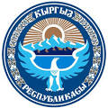 | PROTOCOL  of a meeting of the Council for Business Development and Investment under the Government of Kyrgyz Republic

№____________from December 29 2016

10:00 | Bishkek  The Government House,  Square Hall

Present:  Deputies of Jogorku Kenesh | Asylbaeva G.K., Tulendibaev P.R.
Members of the Government of the Kyrgyz Republic | Abulgaziev M.D., Pankratov O.M., Ahmetov U.T., Batyraliev T.A., Myrashev H.M., Zidaliev D.T.
from the Office of the President of the Kyrgyz Republic | Seyitkasymova R.R.
From ministries and agencies of the Kyrgyz Republic | Mukanbetov S.T., Osmonov Z.B., Sulaimanov A.T., Choduev E.W., Abdykaimov O.A., Tyumenbaev B.R., Sazbakov A.Z., Isakov T.B., Zhumakanov K.T., Zhamankulov A.K., Isakov E.K., Ahmatov S.M., Kozhomberdieva A.T.
From the Office of the Government of the Kyrgyz Republic | Chuikov N.A., Akmataliev A.I., Aaliev A.K., Zheenaliev A.Z., Isakov Z.Y., Murzaliev H.A.
From business associations, donor organizations and secretariat of the council | Koichumanov T.Dzh., Alimzhanova D.I., Commissarov V.A., Uskenbaeva G.T., Musuraliev N.D., Borombaeva E.N., Karabanov G.N., Baltabaev R., Sharsheev I. Sydykov A.K.. Geletyuk I.D., Chekirbaeva Z., Kozlov L., Rosen K., Osavolyuk S., Sydygalieva A., Bisembin D., Hamlin P., Mamatova C., Westergaard K., Dzhanybaeva G., Ermakova R., Brimkulova K.N., Adikova E.O.
I. On execution of decisions of the Council for Business Development and Investment under the Government of the Kyrgyz Republic from October 11, 2016
(Koichumanov, Akhmetov, Osmonov, Zilaliev, Pankratov, Borombaeva, Tyumenbaev, Uskenbaeva, Asylbaeva, Commissioners, Jeenbekov)

Having been informed by T.J. Koichumanov, the Secretary of the Council for Business Development and Investment under the Government of the Kyrgyz Republic on implementation of decisions of the Council for Business Development and Investment under the Government of the Kyrgyz Republic on October 11, 2016, the Council decided to recommend that:

1. The Ministry of Justice of the Kyrgyz Republic in the period prior to March 1, 2017 to present in established order to the Office of the Government of the Kyrgyz Republic:
- A draft resolution of the Government of the Kyrgyz Republic "On Amending Resolution of the Government of the Kyrgyz Republic" On approval of standards for compensation of expenses in cases of loss of agricultural production, established by the regulation of the Government of the Kyrgyz Republic from January 5, 2016 # 1";
- Draft Law of the Kyrgyz Republic "On Amendments to the Law of the Kyrgyz Republic" On transfer (transformation) of land. "

2. State Tax Service under the Government of the Kyrgyz Republic in the period prior to January 5, 2017 to make a draft decision to the Office of Government of the Kyrgyz Republic on approval of technical requirements for computer systems that will provide online data transmission.

3. Interdepartmental commission on coordinating issues of tourism development, established by an order of the Prime Minister of the Kyrgyz Republic from February 24, 2016 # 98, to hold the next meeting in January 2017 in order to promptly address issues raised by the business community.

4. The Ministry of Economy of the Kyrgyz Republic to take into account opinions of the Kyrgyz Republic’s business community to ensure maximum involvement of representatives of business associations in a process of developing a new version of the Tax Code of the Kyrgyz Republic.
Control over an execution of the above points is to be to assigned to the following departments of the Office of the Government of the Kyrgyz Republic:
- Paragraph 1 - industry department of fuel and energy complex and subsoil use;
- Paragraph 2- financial and credit policy department;
- Paragraph 3 - department of education, culture and sports;
- Paragraph 4 - economy and investment department.

- On problems of market surveillance of imported agricultural products from EACU Member States and an elimination of the root causes in introduction of restrictions on imports of products made by domestic manufacturers in the EACU Member States.
(Sazbakov, Alimzhanova, Jeenbekov)

Having heard and discussed information provided by A.Z. Sazbakov, the Deputy Minister of Economy of the Kyrgyz Republic, executive director of the Food Industry Association and D.I. Alimzhanova, and in light of the discussion that followed, it was decided to recommend:

1. The Ministry of Economy of the Kyrgyz Republic, the Ministry of Agriculture, Food and Land Reclamation of the Kyrgyz Republic, the Ministry of Health of the Kyrgyz Republic, the State Inspectorate for veterinary and phytosanitary safety under the Government of the Kyrgyz Republic in the period prior to January 25, 2017 to provide to the Office of the Government of the Kyrgyz Republic:
- Draft decisions of the Government of the Kyrgyz Republic on procedures of state control for food production and related requirements for the processes of production, storage, transportation, sale and disposal;
- Draft decisions of the Government of the Kyrgyz Republic for state registration of industrial facilities engaged in production, storage and transportation of unprocessed food (edible) animal feed;
- Proposals for introduction of mechanisms for cooperation between the EACU Member States to prevent tan unjustified ban on export of agricultural products from the Kyrgyz Republic to the EACU Member States.

Assign control over an execution of this order to Department of economy and investments under the Government Office of the Kyrgyz Republic.

- On the optimization of the raid tax control
(Uskenbaeva, Tyumenbaev, Osmonov, Jeenbekov)

Having been informed G.T. Uskenbaeva, the President of the Association of suppliers and distributors, B.R. Tyumenbaev, the Deputy Minister of Economy of the Kyrgyz Republic, and in light of the discussion that followed, it was decided to recommend:

1. The Ministry of Economy of the Kyrgyz Republic together with the State Tax Service under the Government of the Kyrgyz Republic in the period prior to March 1, 2017 to consider proposals in established order presented by the Association of suppliers and distributors and introduce draft resolution to the Government of the Kyrgyz Republic on harmonization in accordance with requirements of the Tax Code of the Kyrgyz Republic and Resolution on a procedure for registering and documenting raid tax control, approved by Resolution of the Government of the Kyrgyz Republic on April 7, 2011 #144.

Assign control over execution of this order to Department of finance and credit policy under the Office of the Government of the Kyrgyz Republic.

On approval of Work Plan of the Council for Business Development and Investment under the Government of the Kyrgyz Republic for 2017
(Koichumanov, Musuraliev, Jeenbekov)

Having been informed by T.J. Koichumanov, the Secretary of the Council for Business Development and Investment under the Government of the Kyrgyz Republic, and in light of the discussion that followed, it was decided to recommend:

1. Approve Work Plan of the Council for Business Development and Investment Plan under the Government of the Kyrgyz Republic for 2017.

Prime Minister of the Kyrgyz Republic,
Chairman of the Council of the
Business Development and Investment
Under the Government of the
Kyrgyz Republic S.Sh. Jeenbekov

Secretary of the Council
of Business Development and Investment
under the Government of KR T. Dzh. Koichumanov

